Application Deployment

(Deploy the given react application to a production ready state)

Repo URL: <https://github.com/sriram-R-krishnan/devops-build>

**Step 1**: Dockerize the given application by creating a docker file.

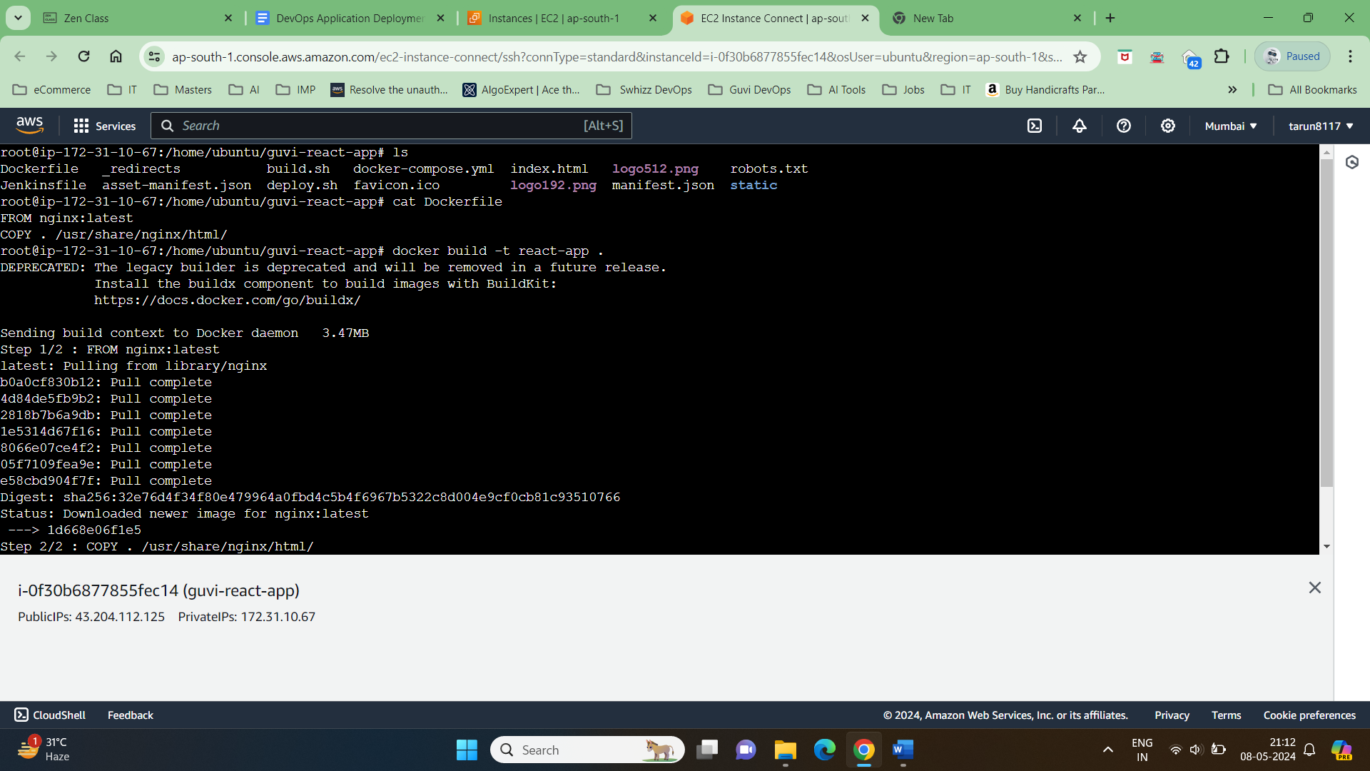

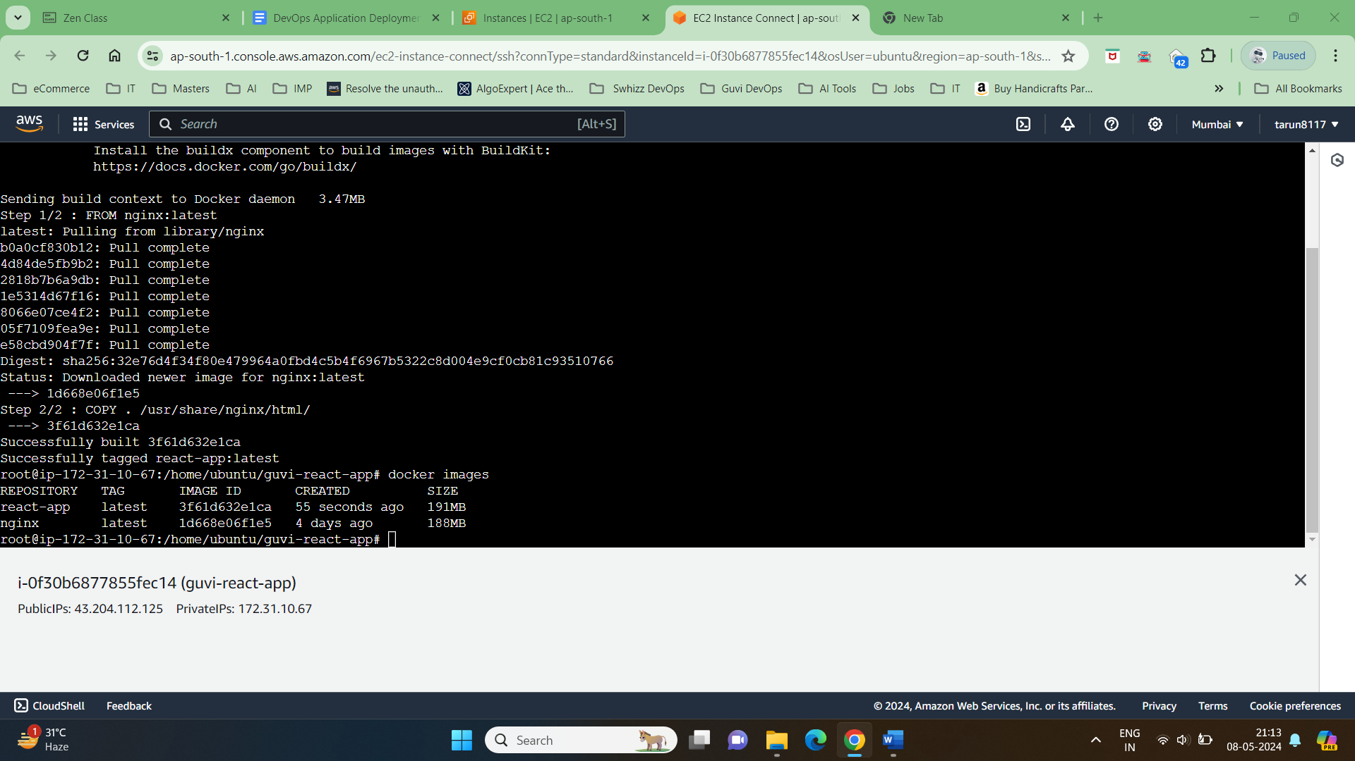

**Step 2**: Create a docker-compose file to use the above image.

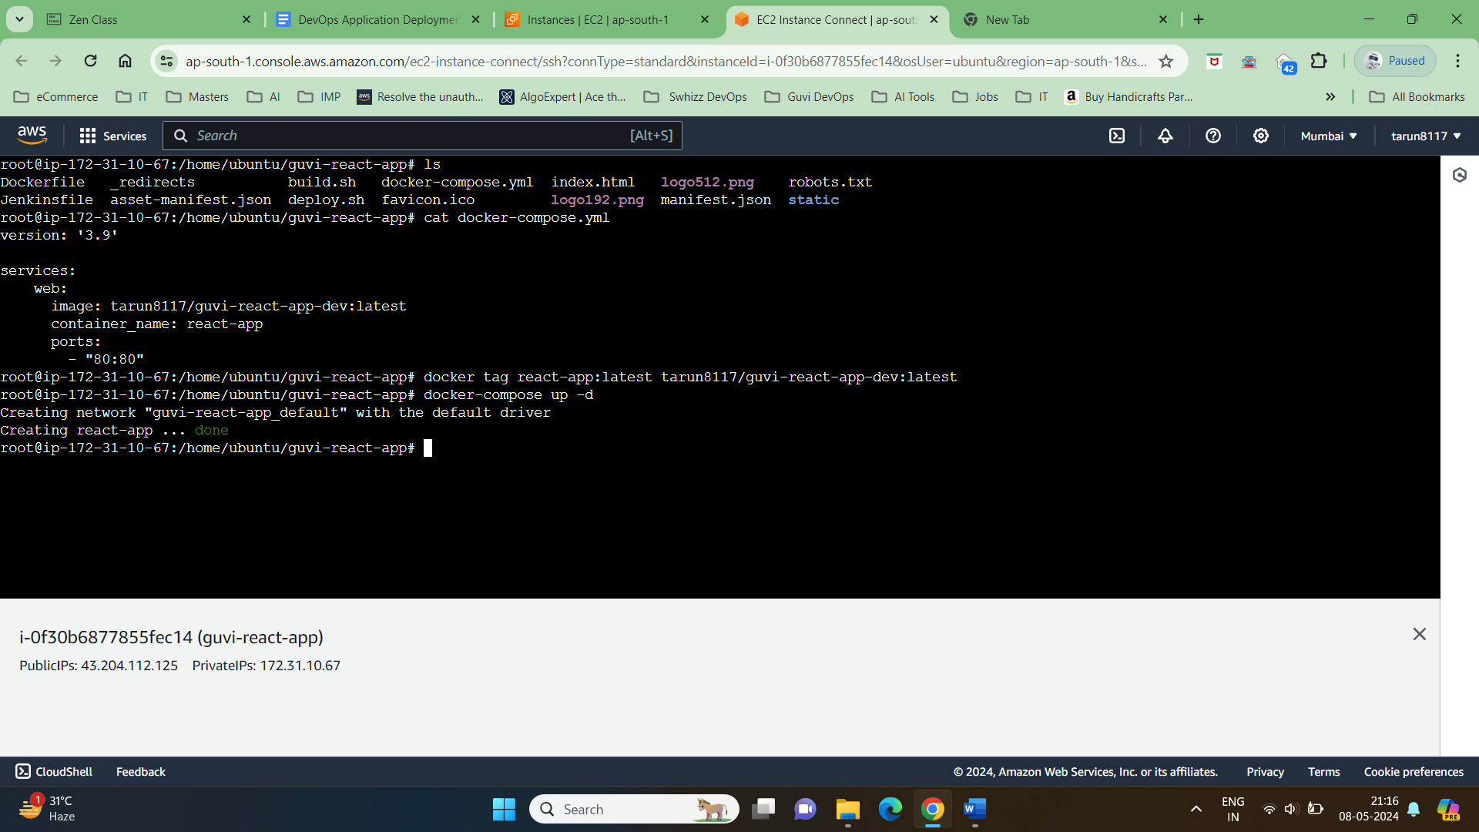

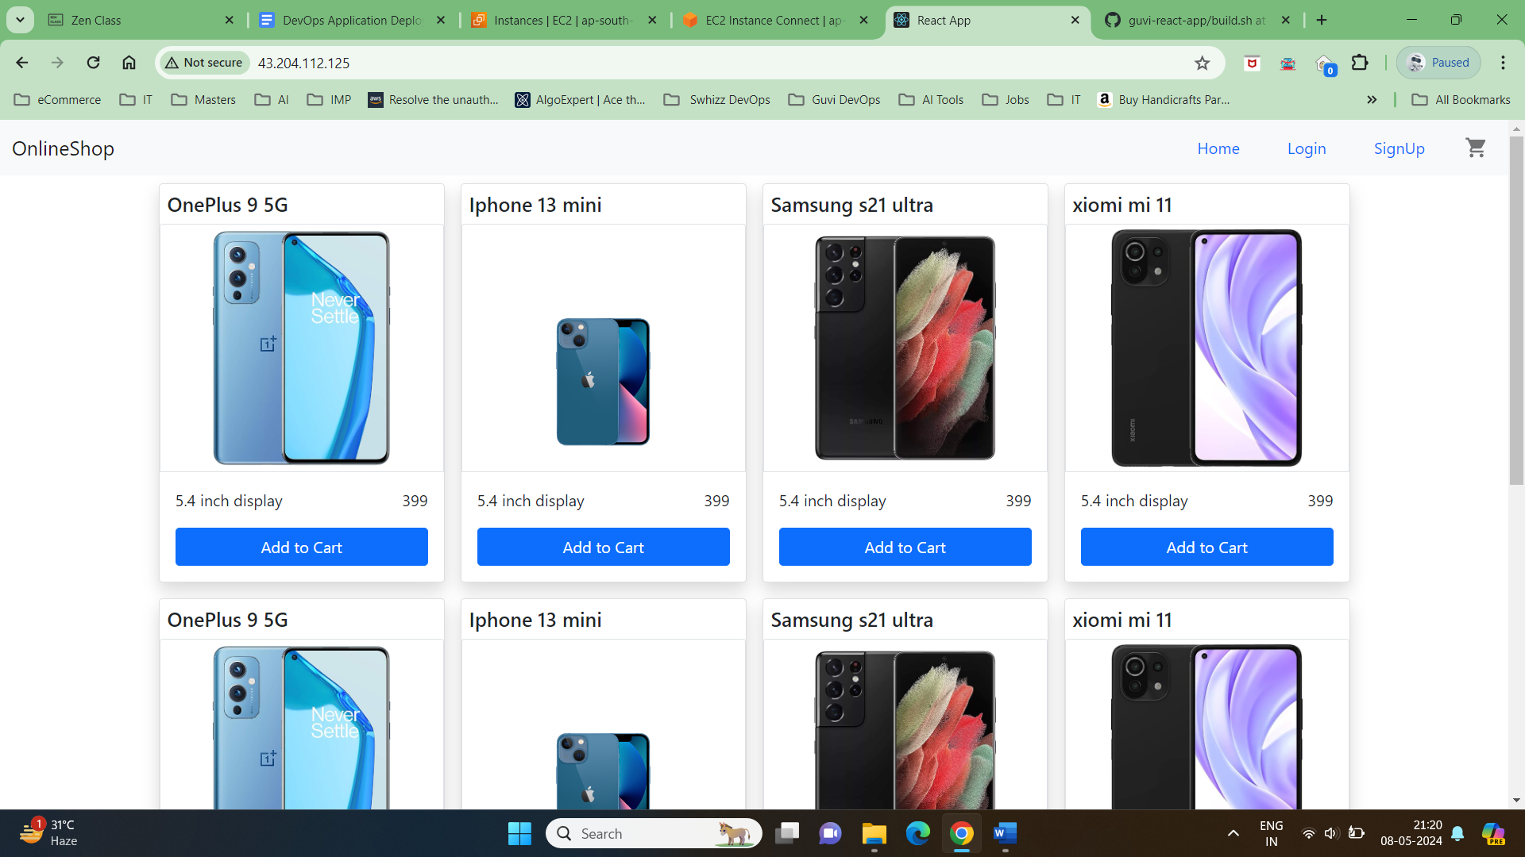

**Step 3**: Write 2 scripts – **build.sh** for building docker images and **deploy.sh** for deploying the image to server.

You need to generate a docker hub token to use it in the below script.

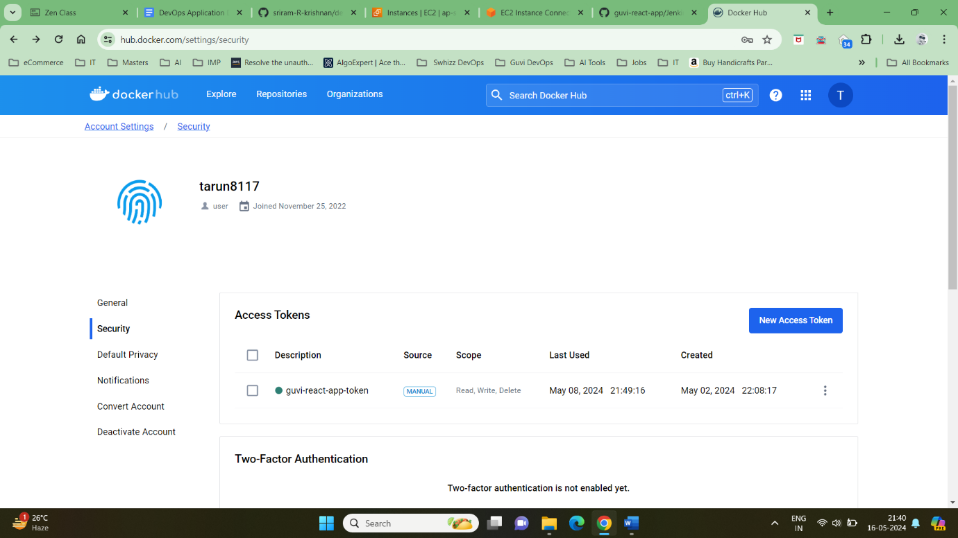

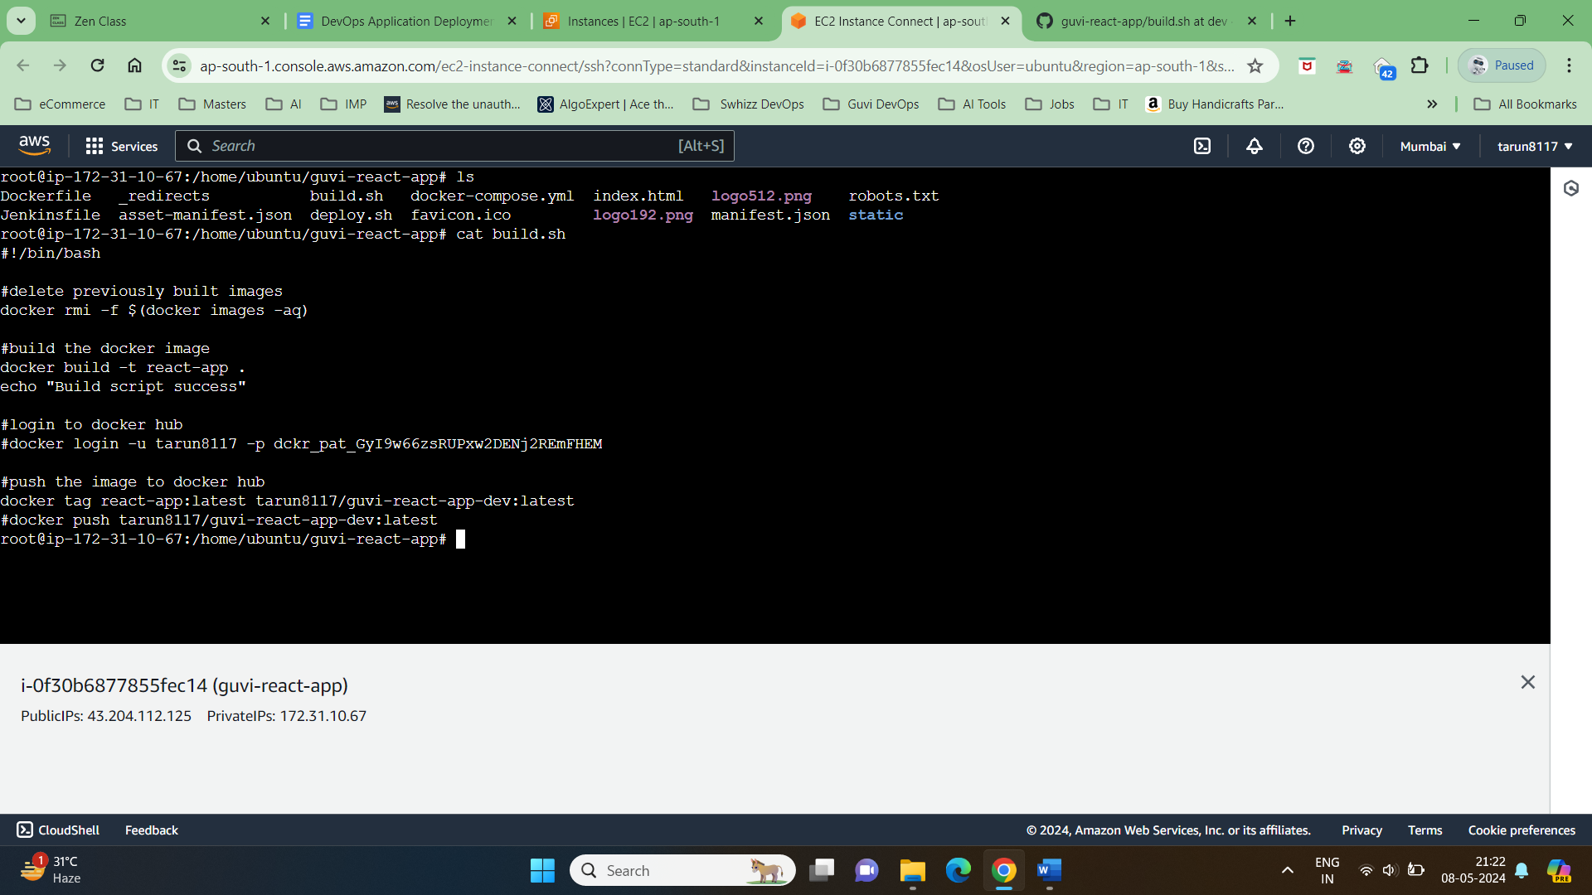

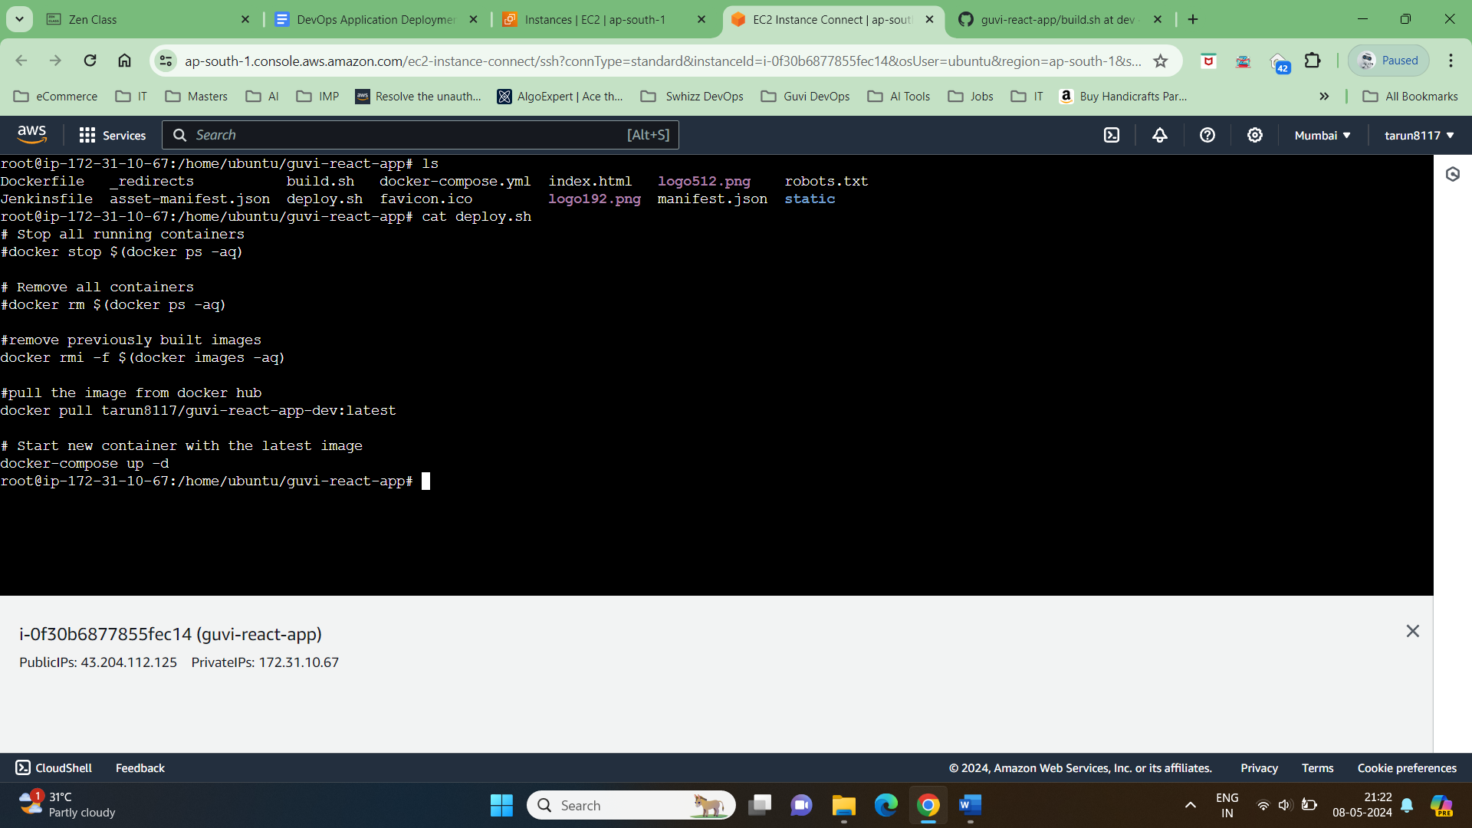

**Step 4**: Push the code to github dev branch.

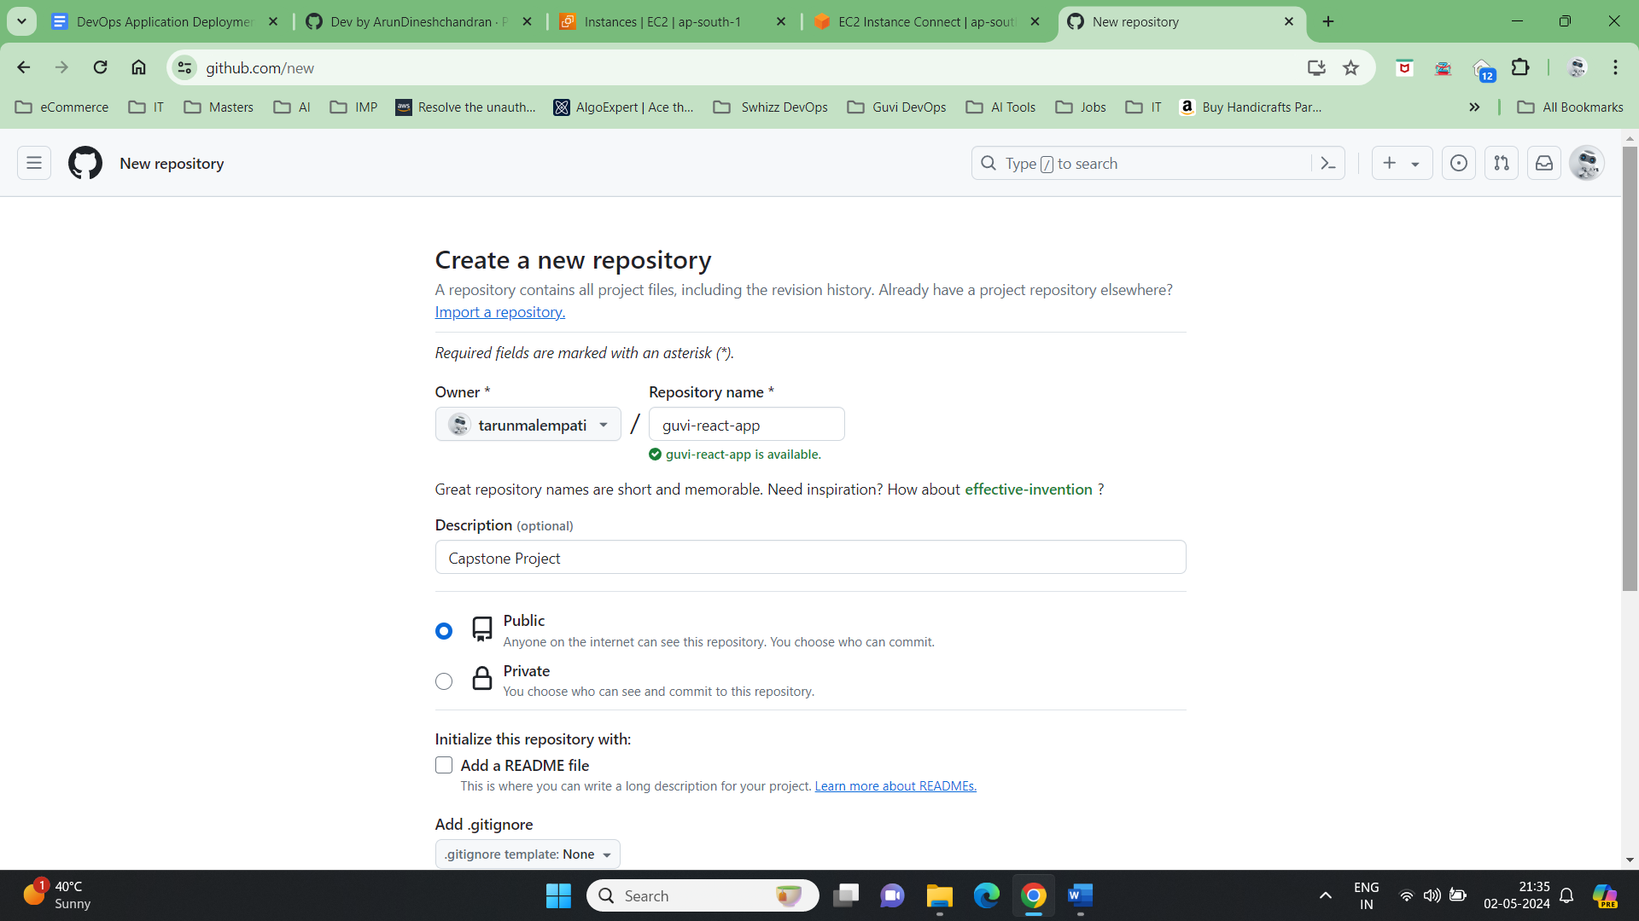

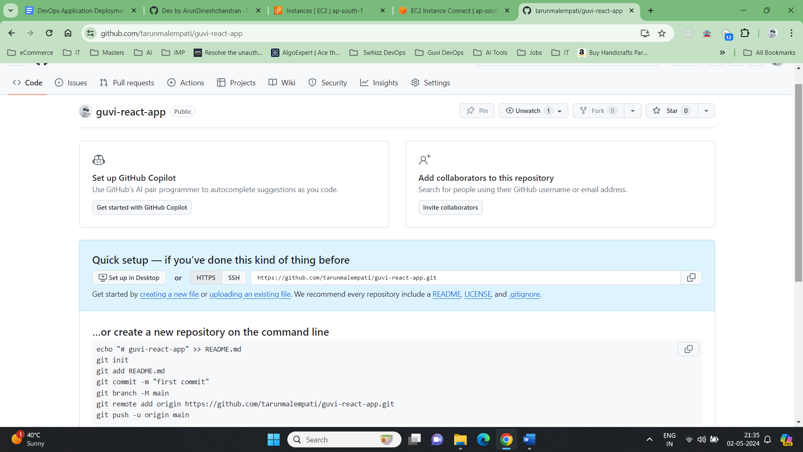

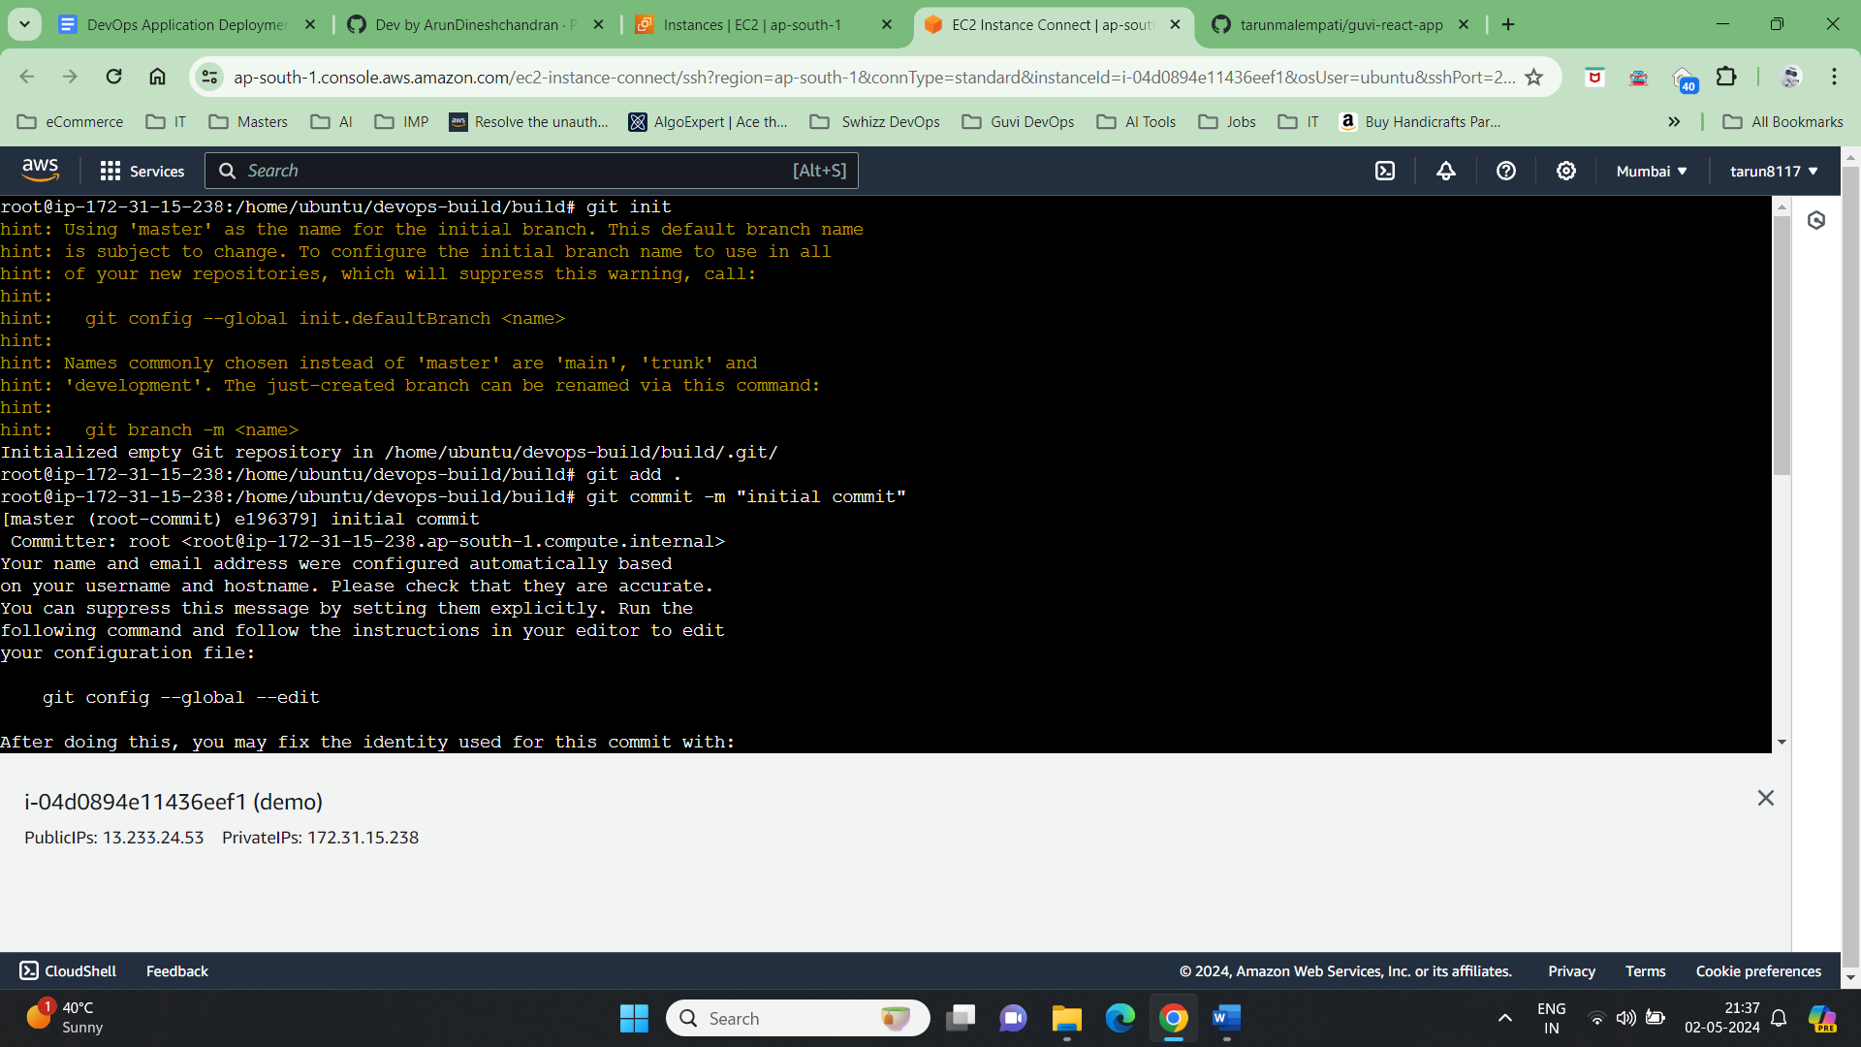

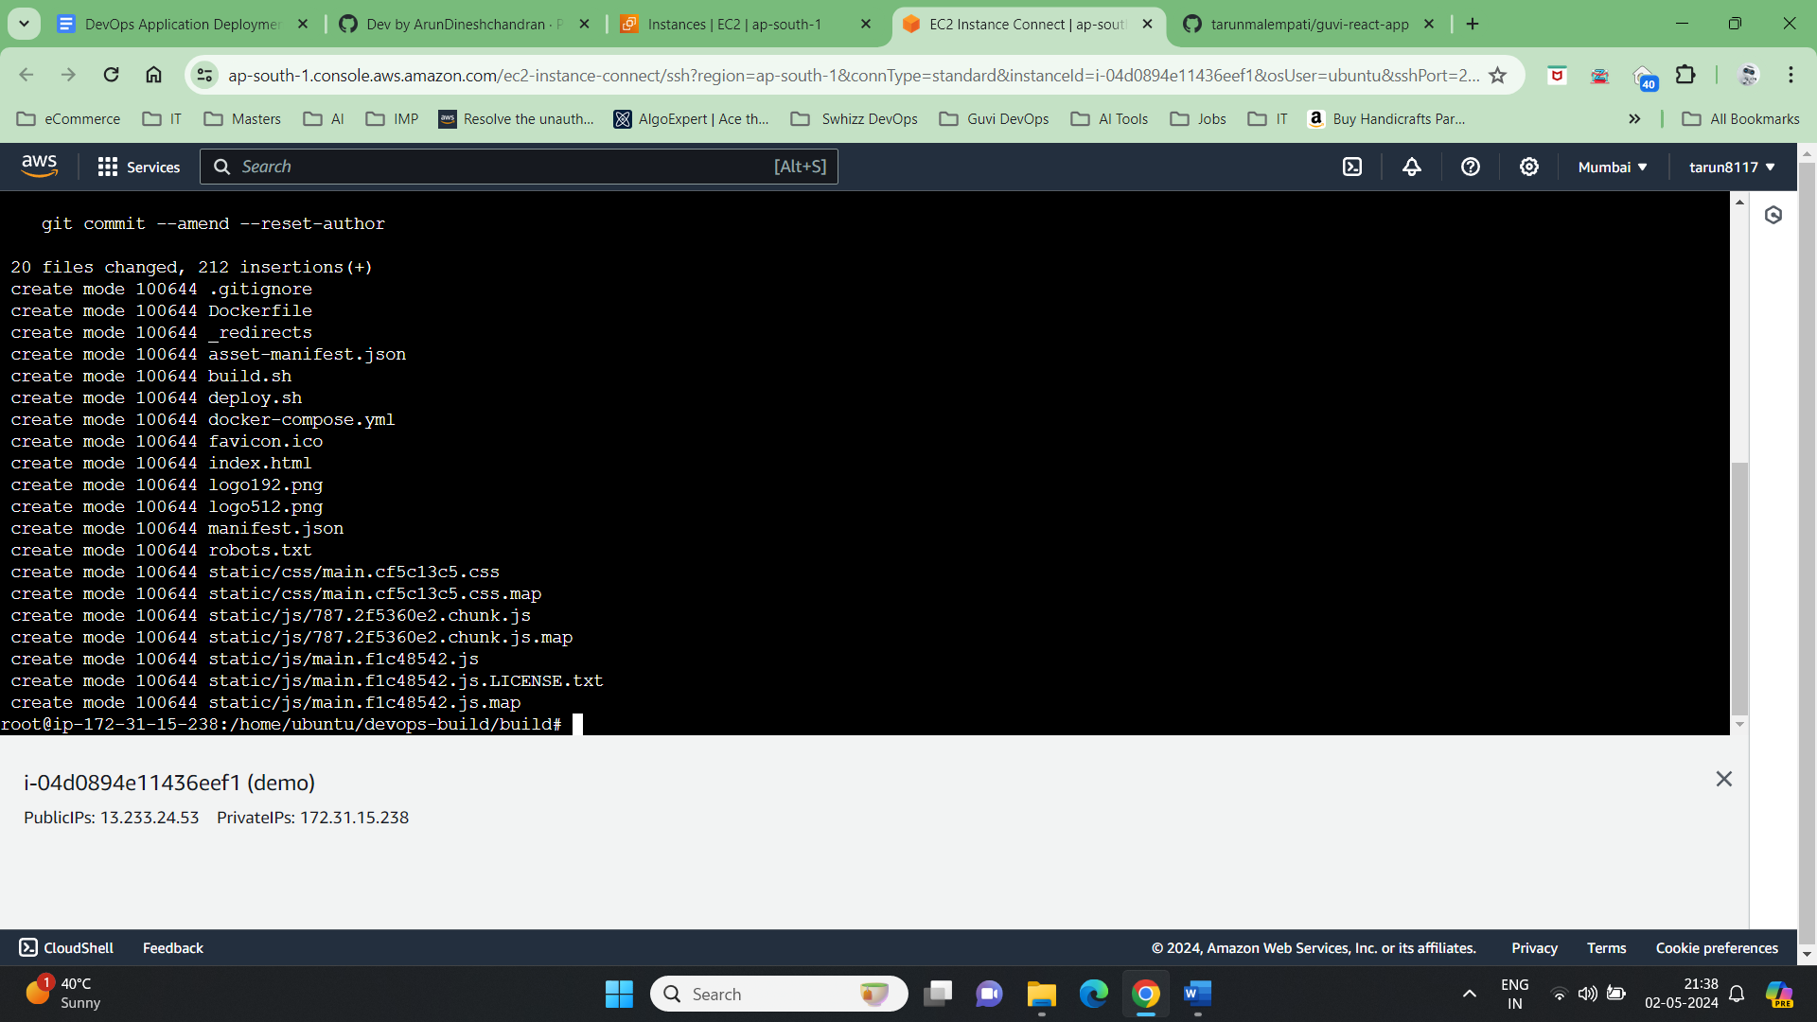

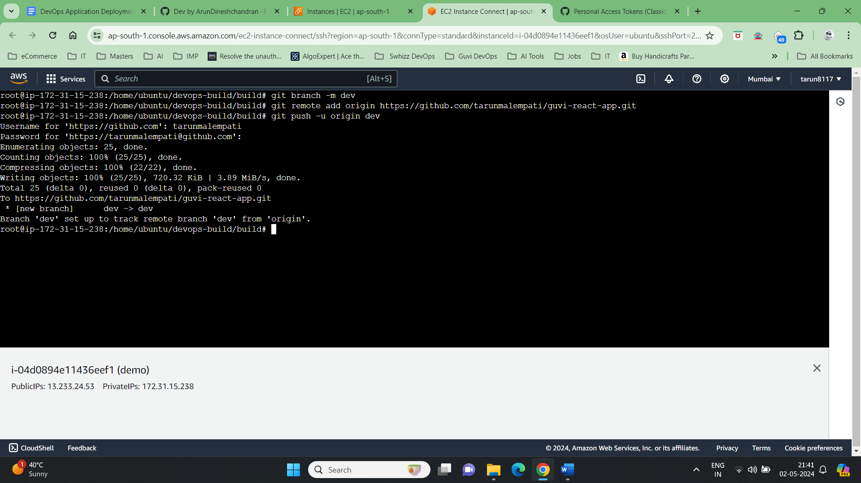

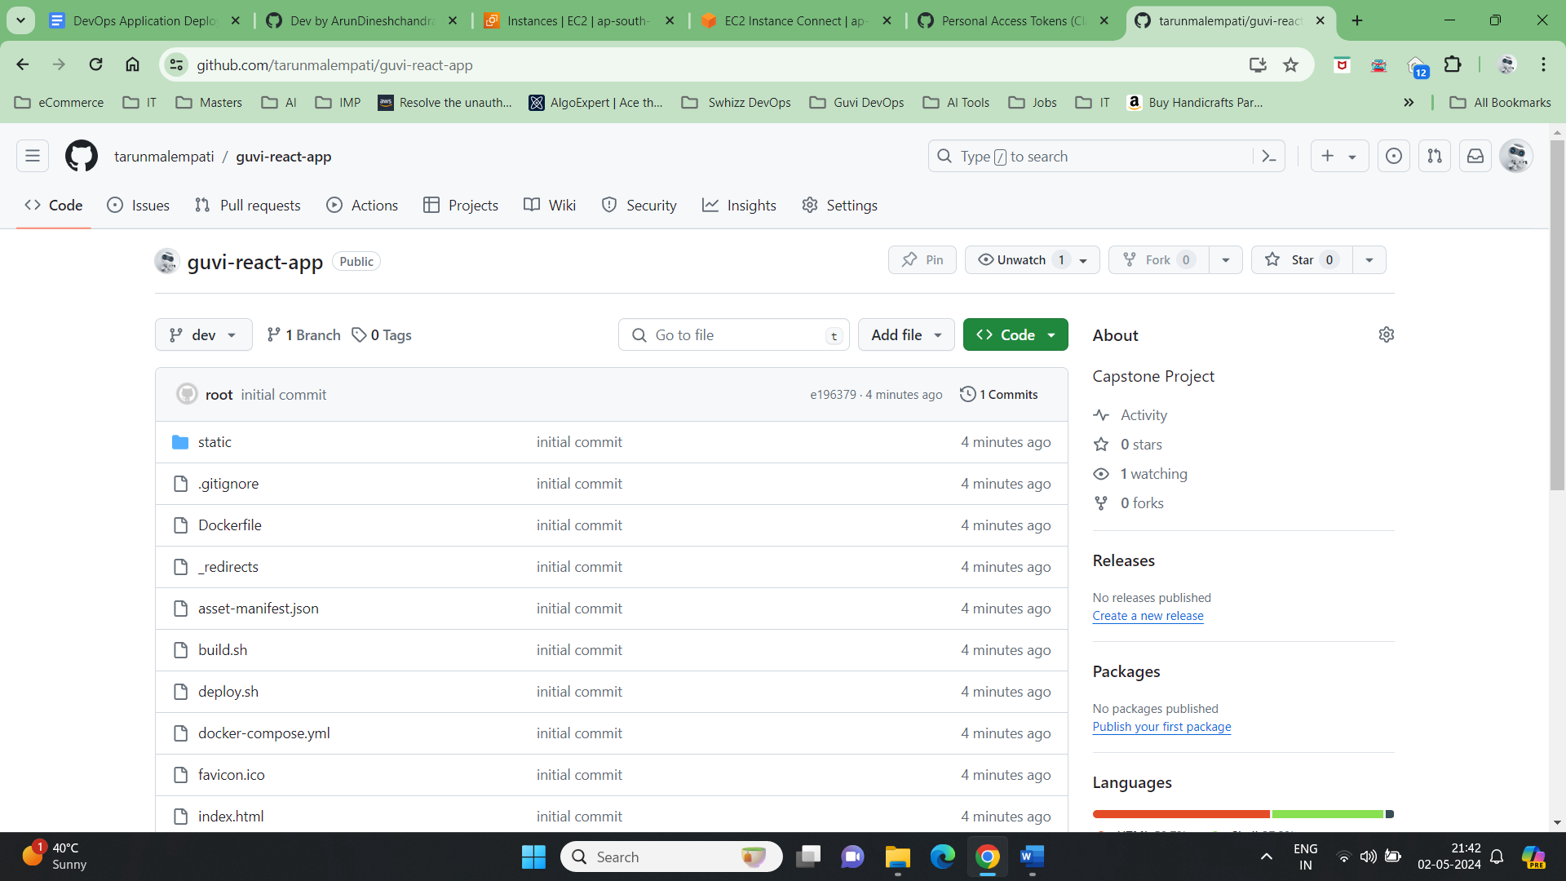

**Step 5**: Create 2 repos “dev” and “prod” to push images. “Prod” repo must be private and “dev” repo can be public.

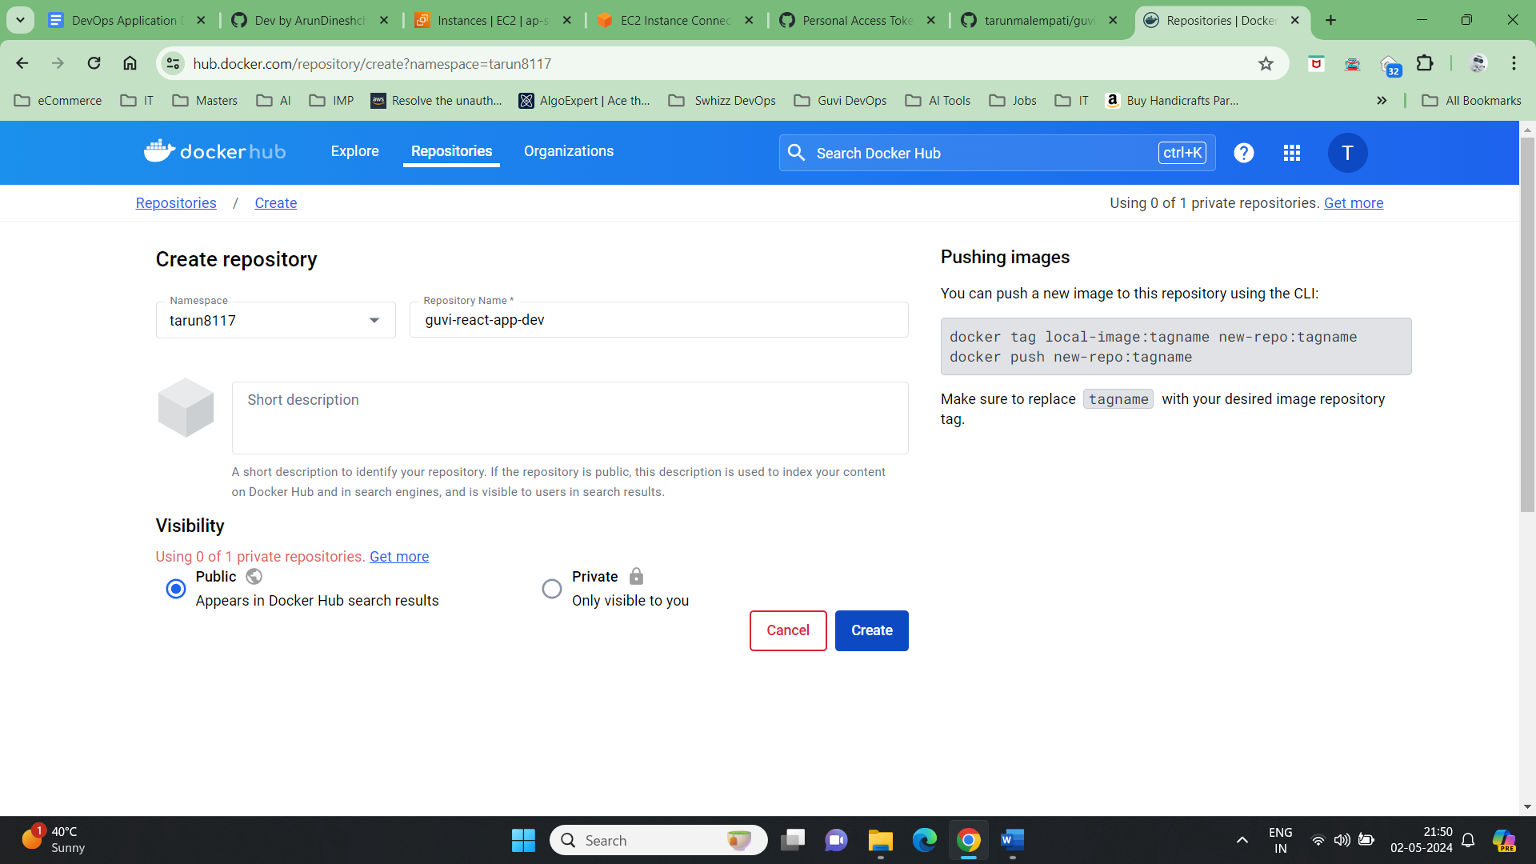

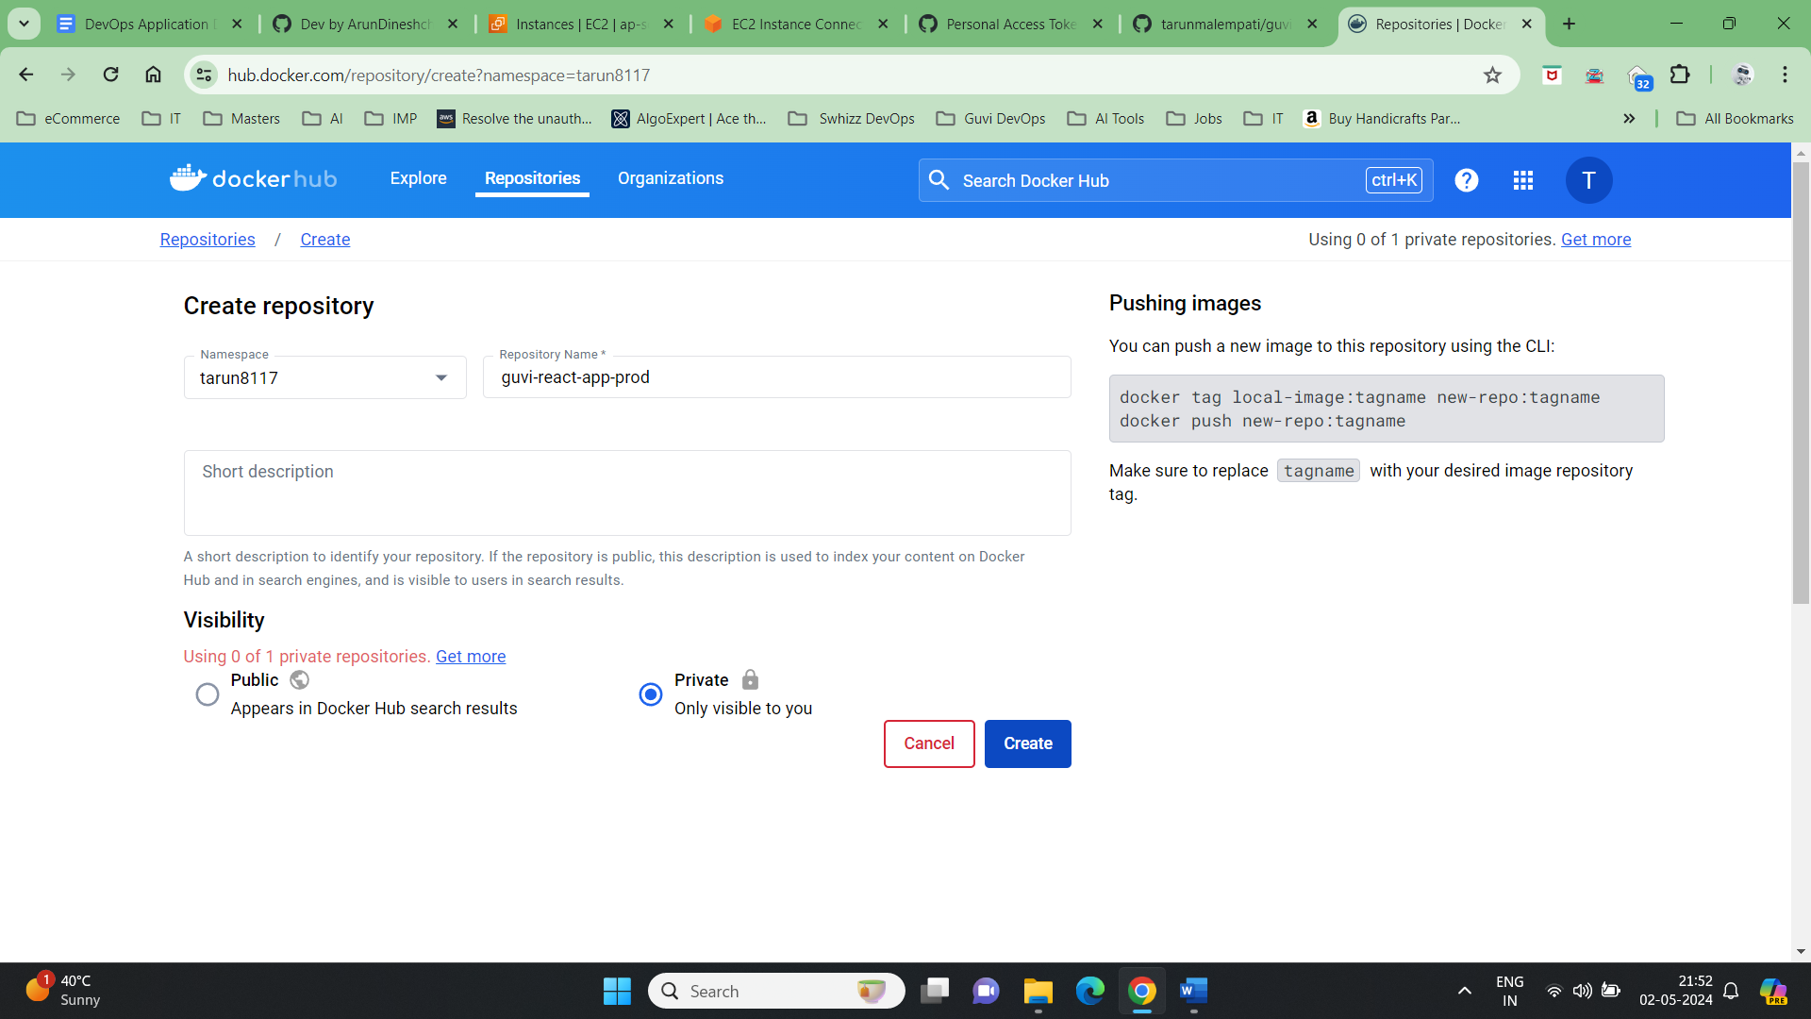

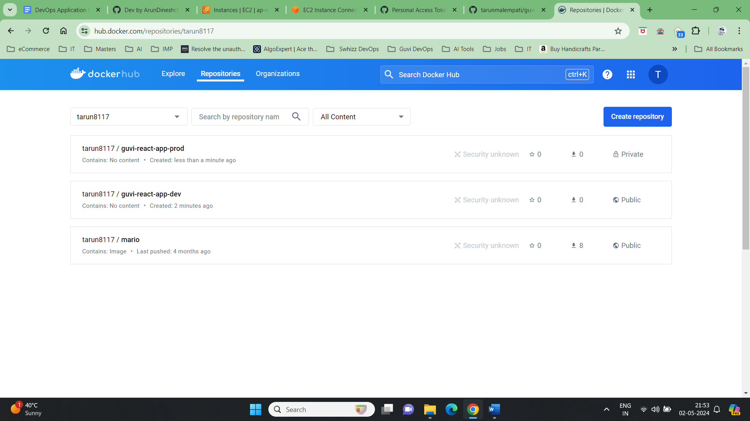

**Step 6**: Install and configure jenkins build step as per needs to build, push and deploy the application.

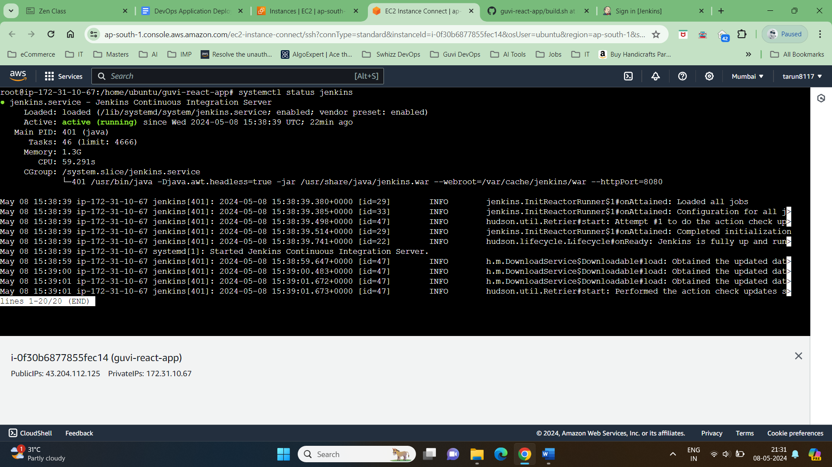

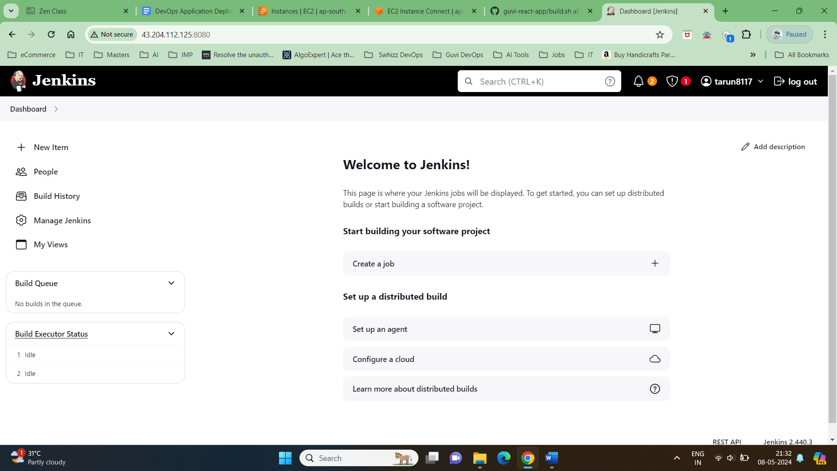

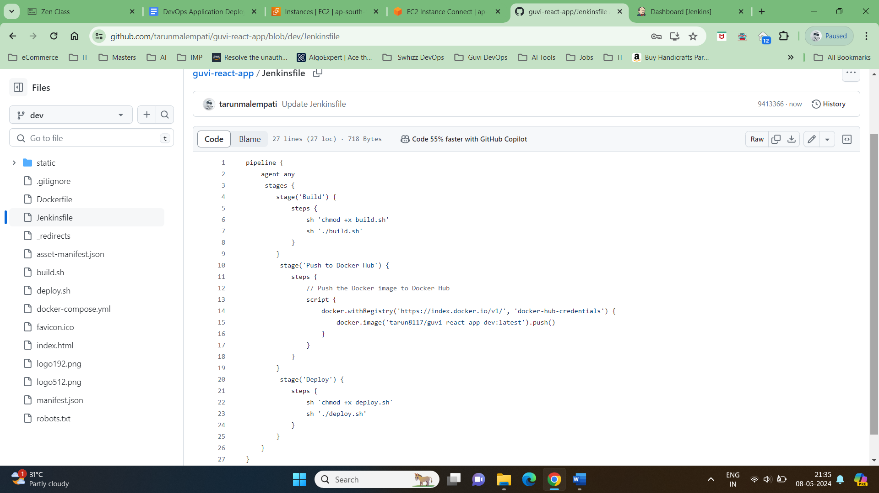

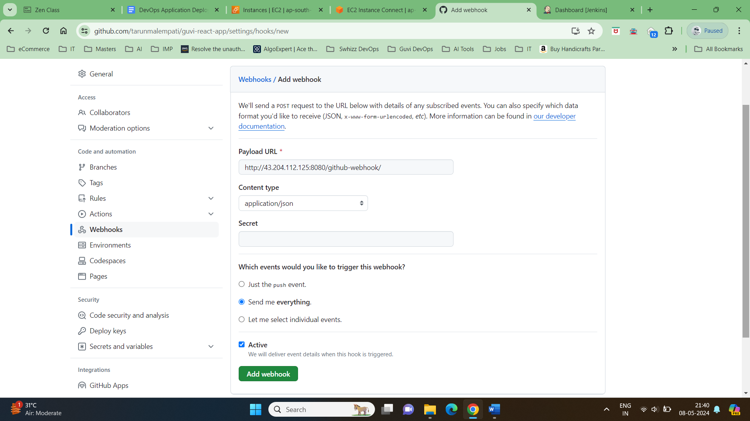

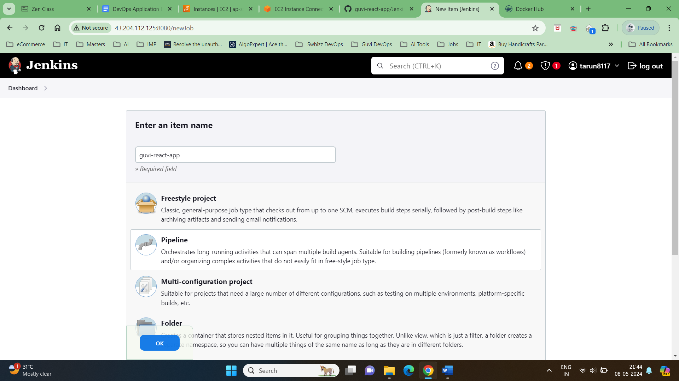

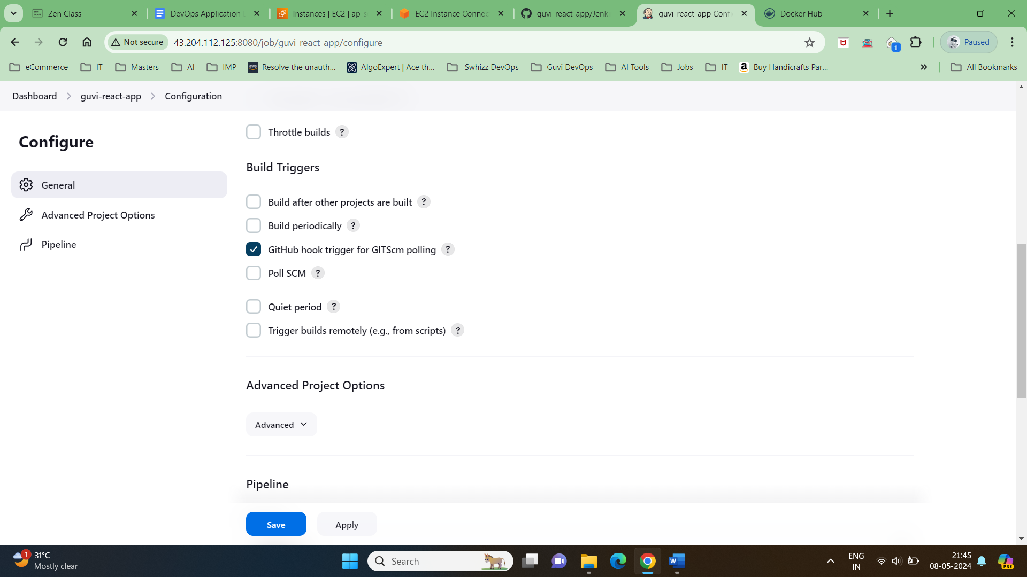

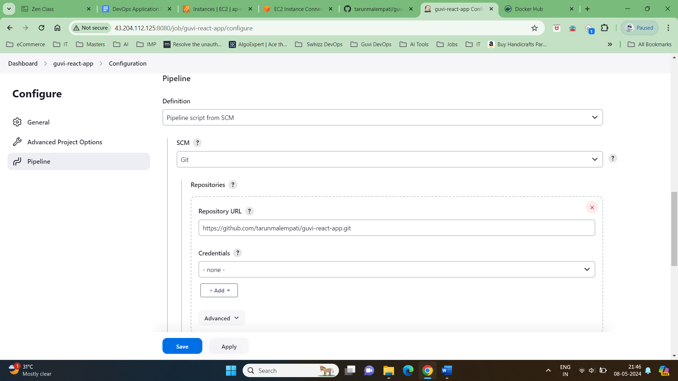

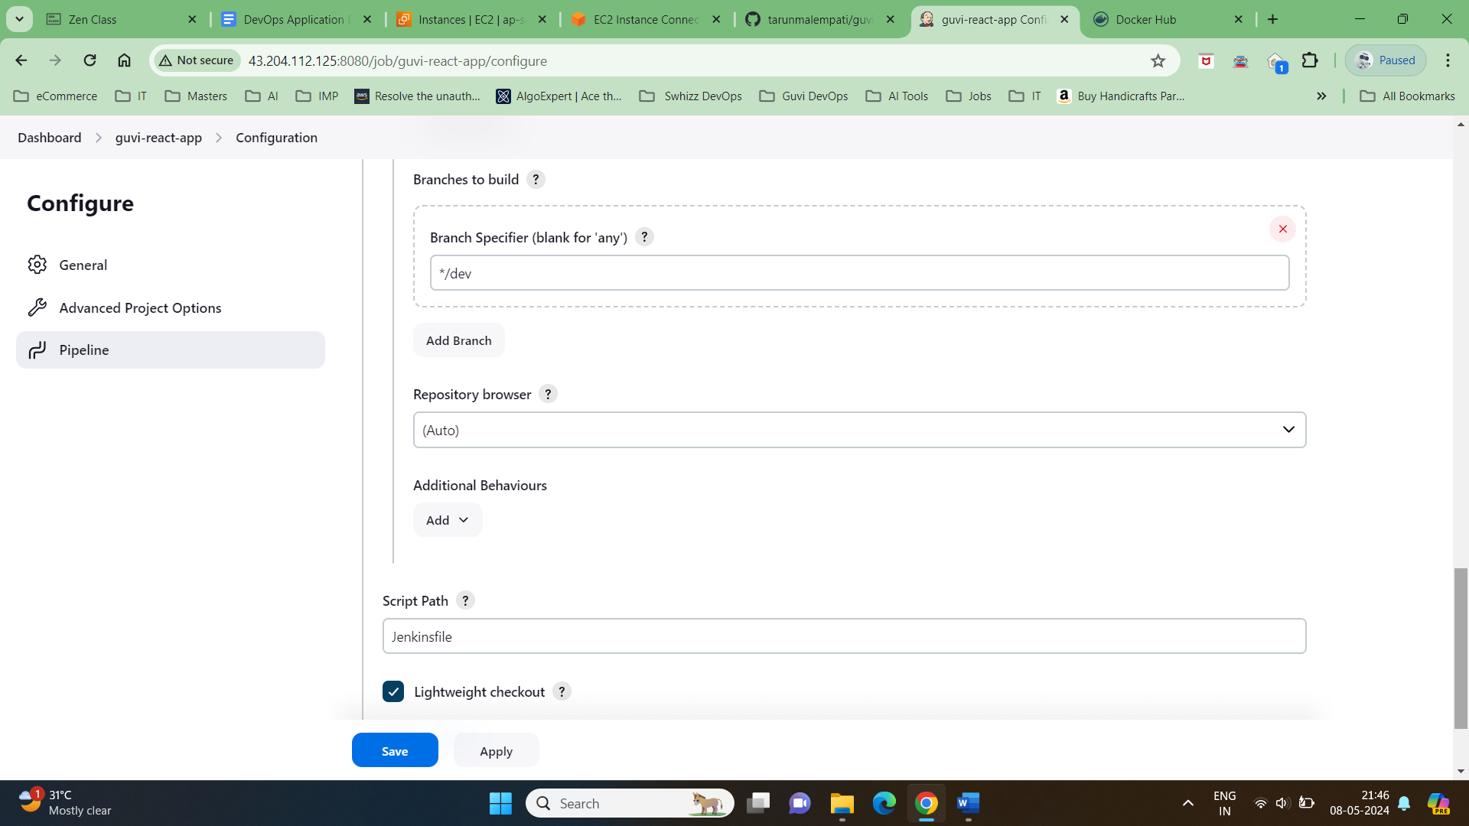

Run the command **usermod -aG docker jenkins** to add the jenkins user to docker group. This command will allow jenkins to run docker commands.

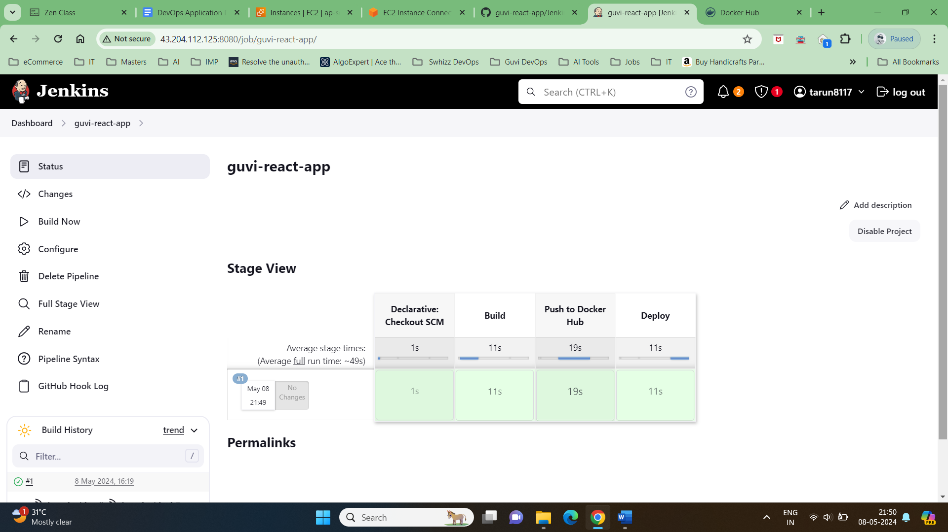

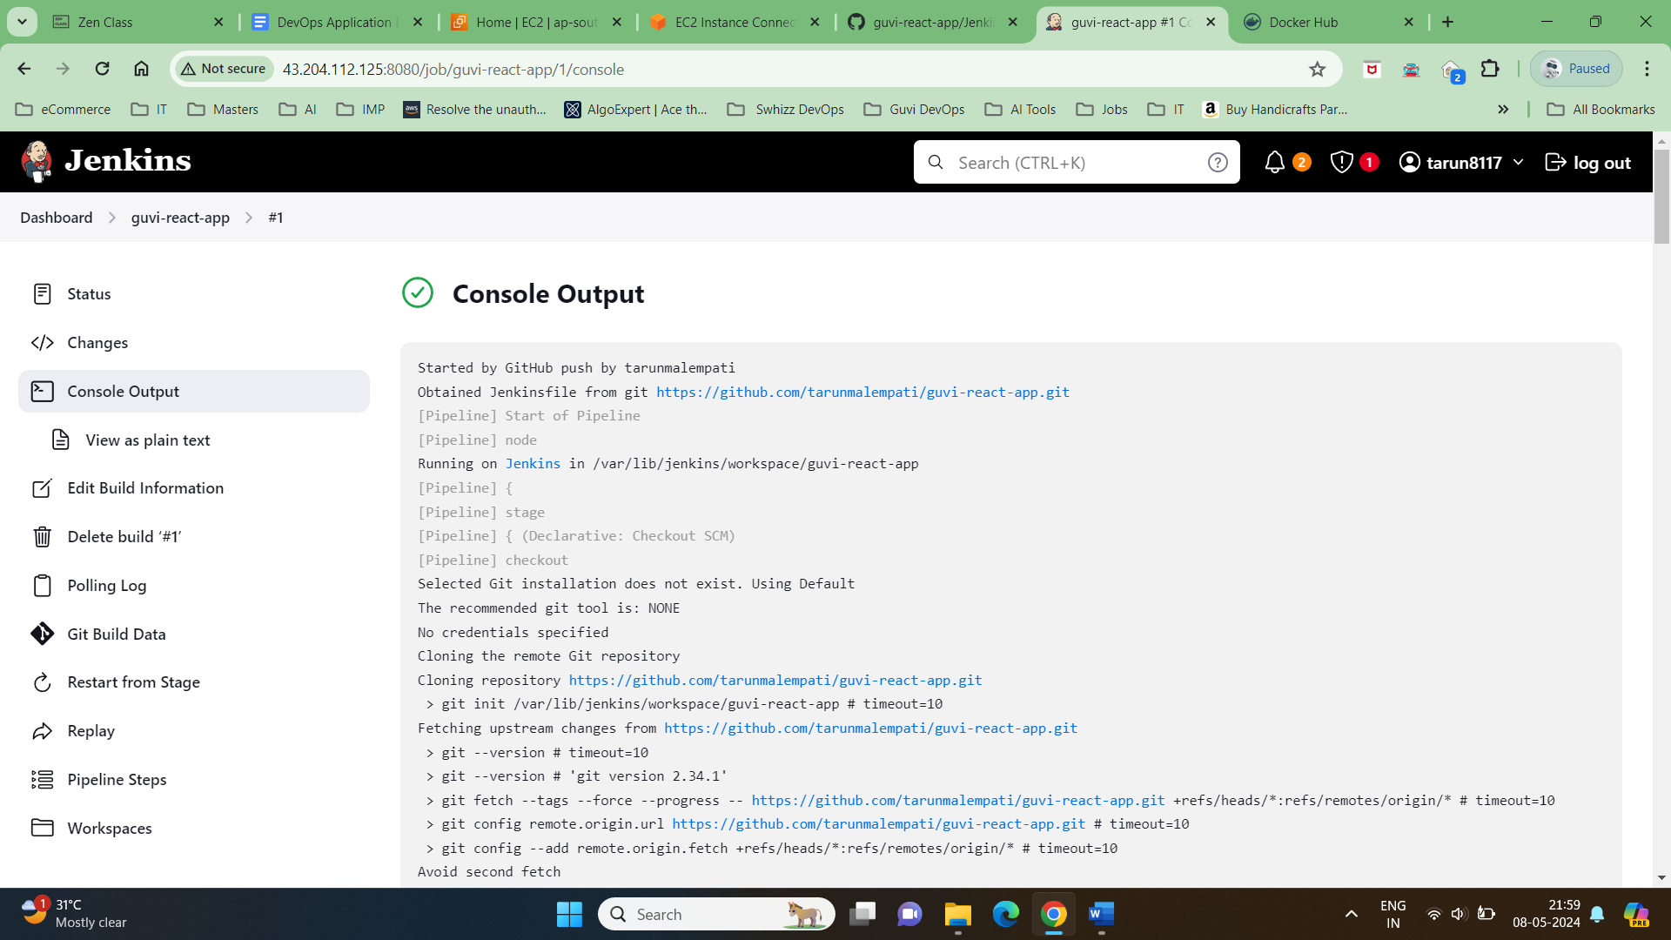

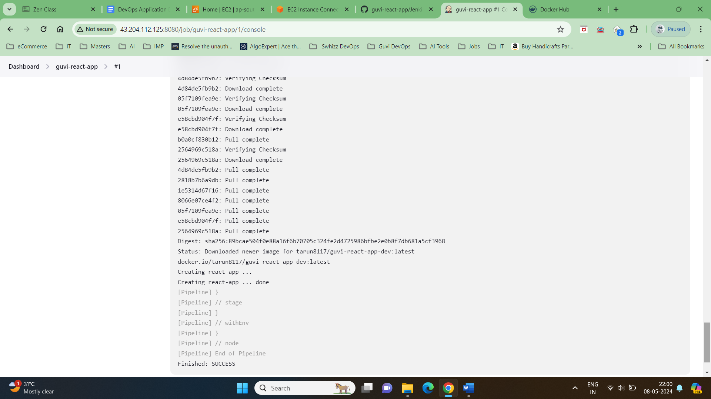

Jenkins job will trigger automatically when you commit in the github repositroy.

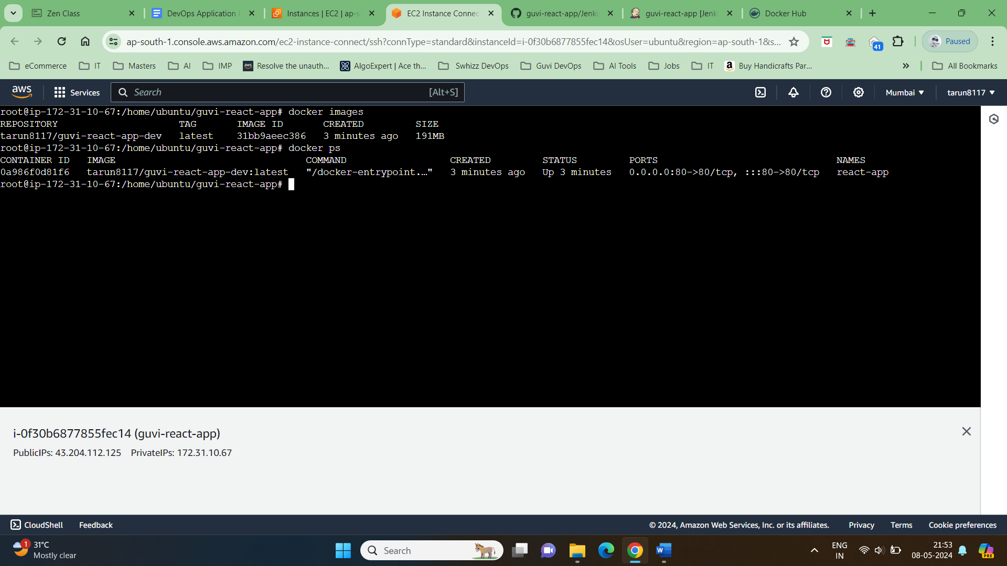

**Step 7**: Launch EC2 instance and deploy the react application.

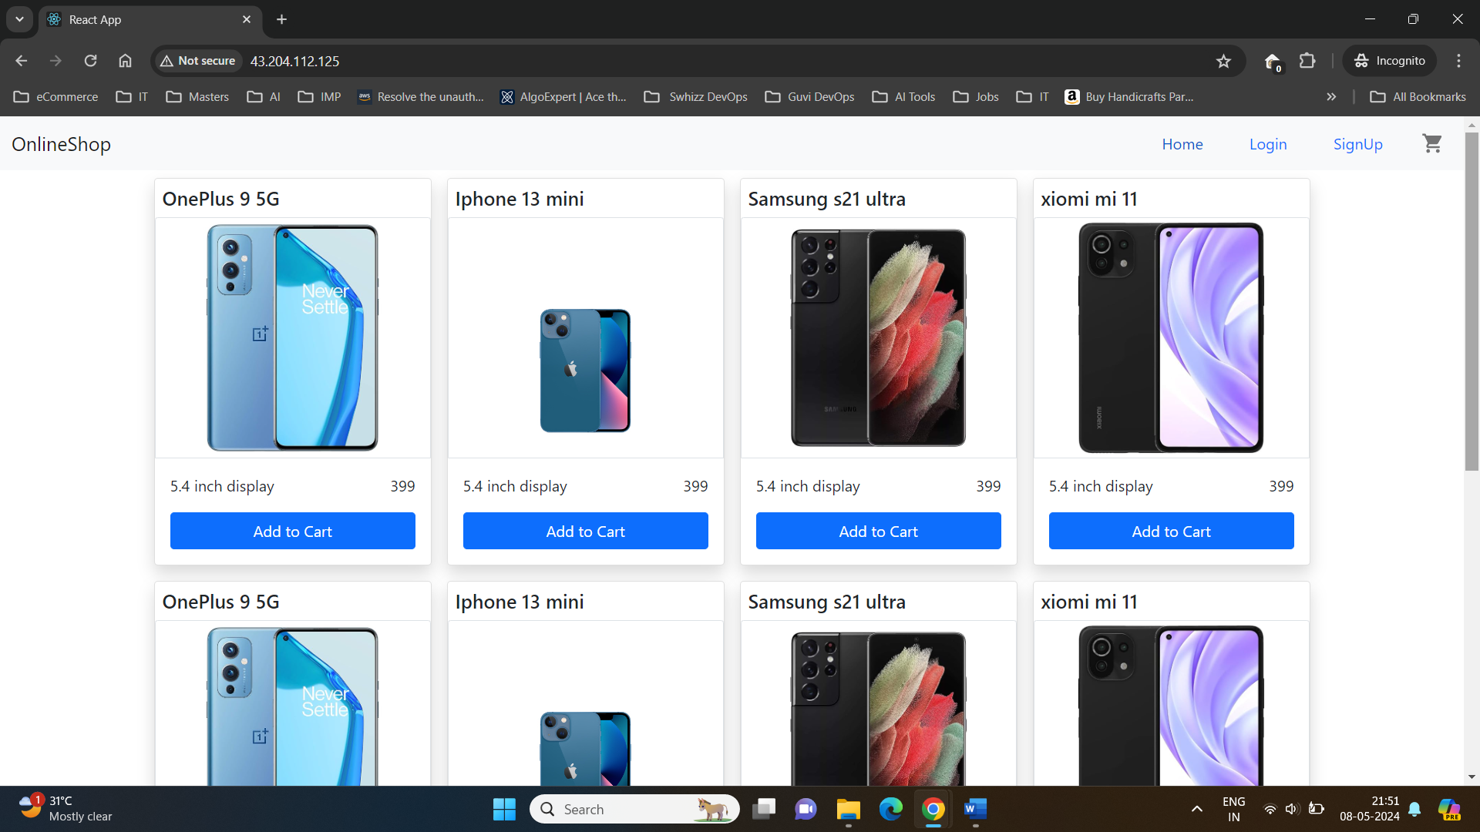

**Step 8**: Setup a monitoring system to check the health status of the application.

Install prometheus

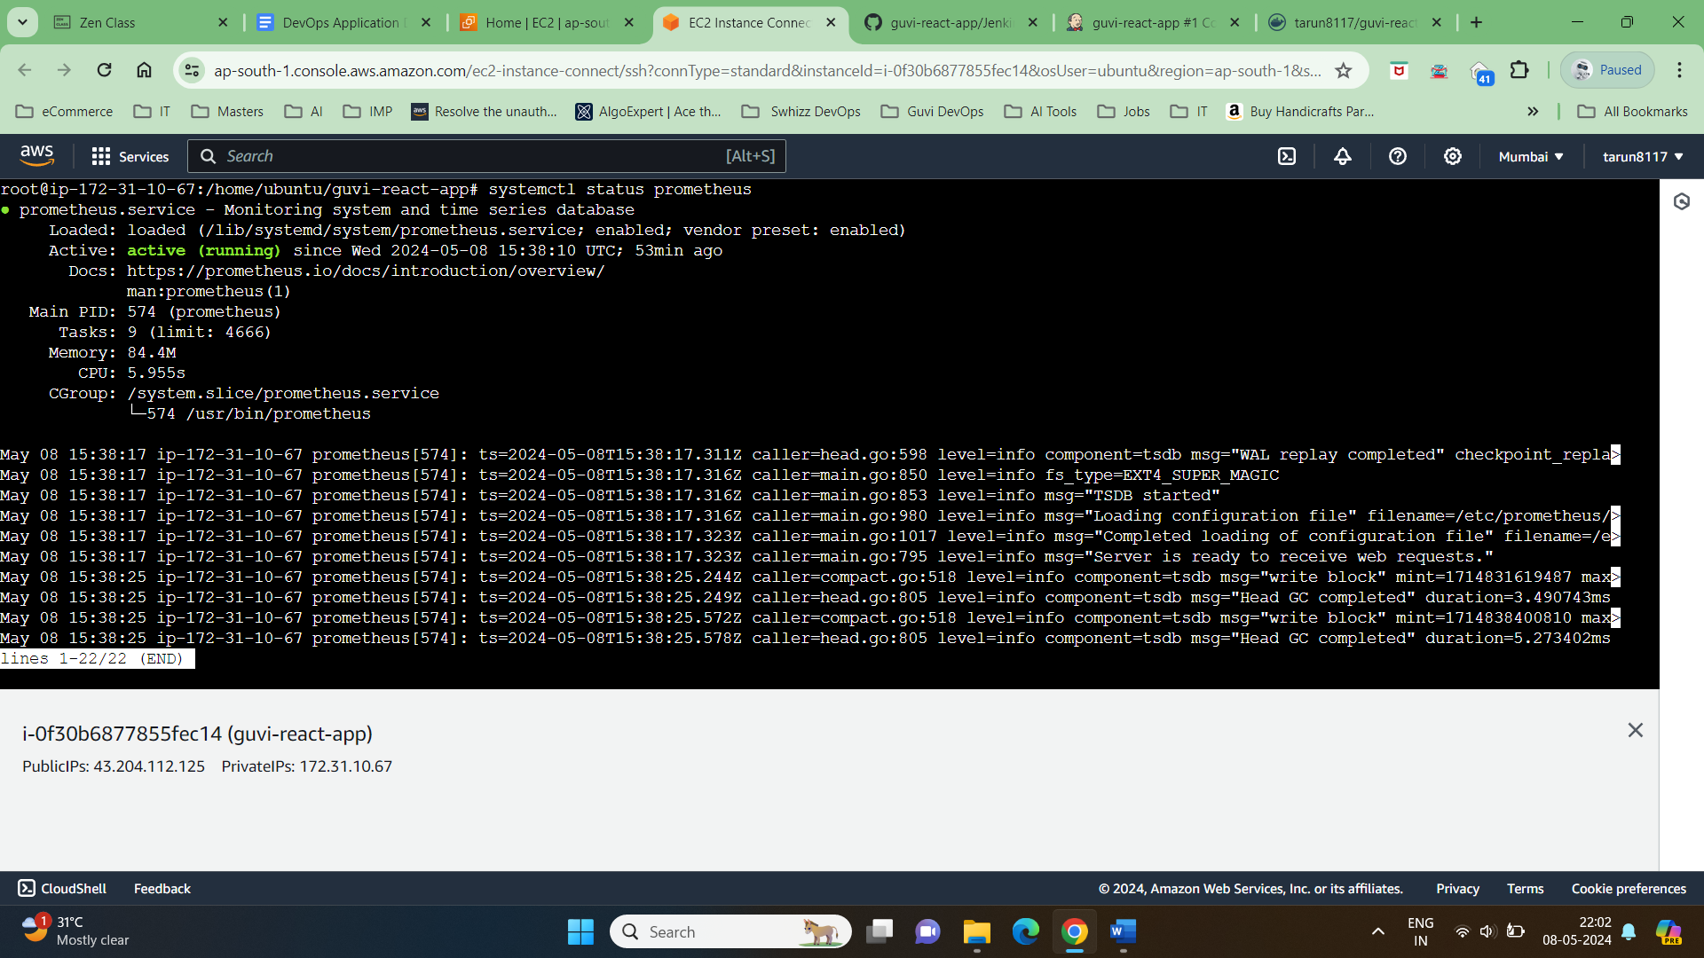

Install prometheus alert-manager

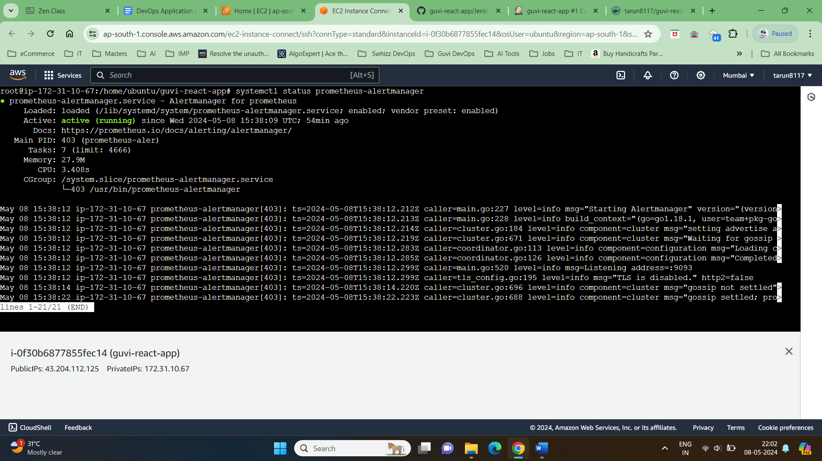

Install grafana

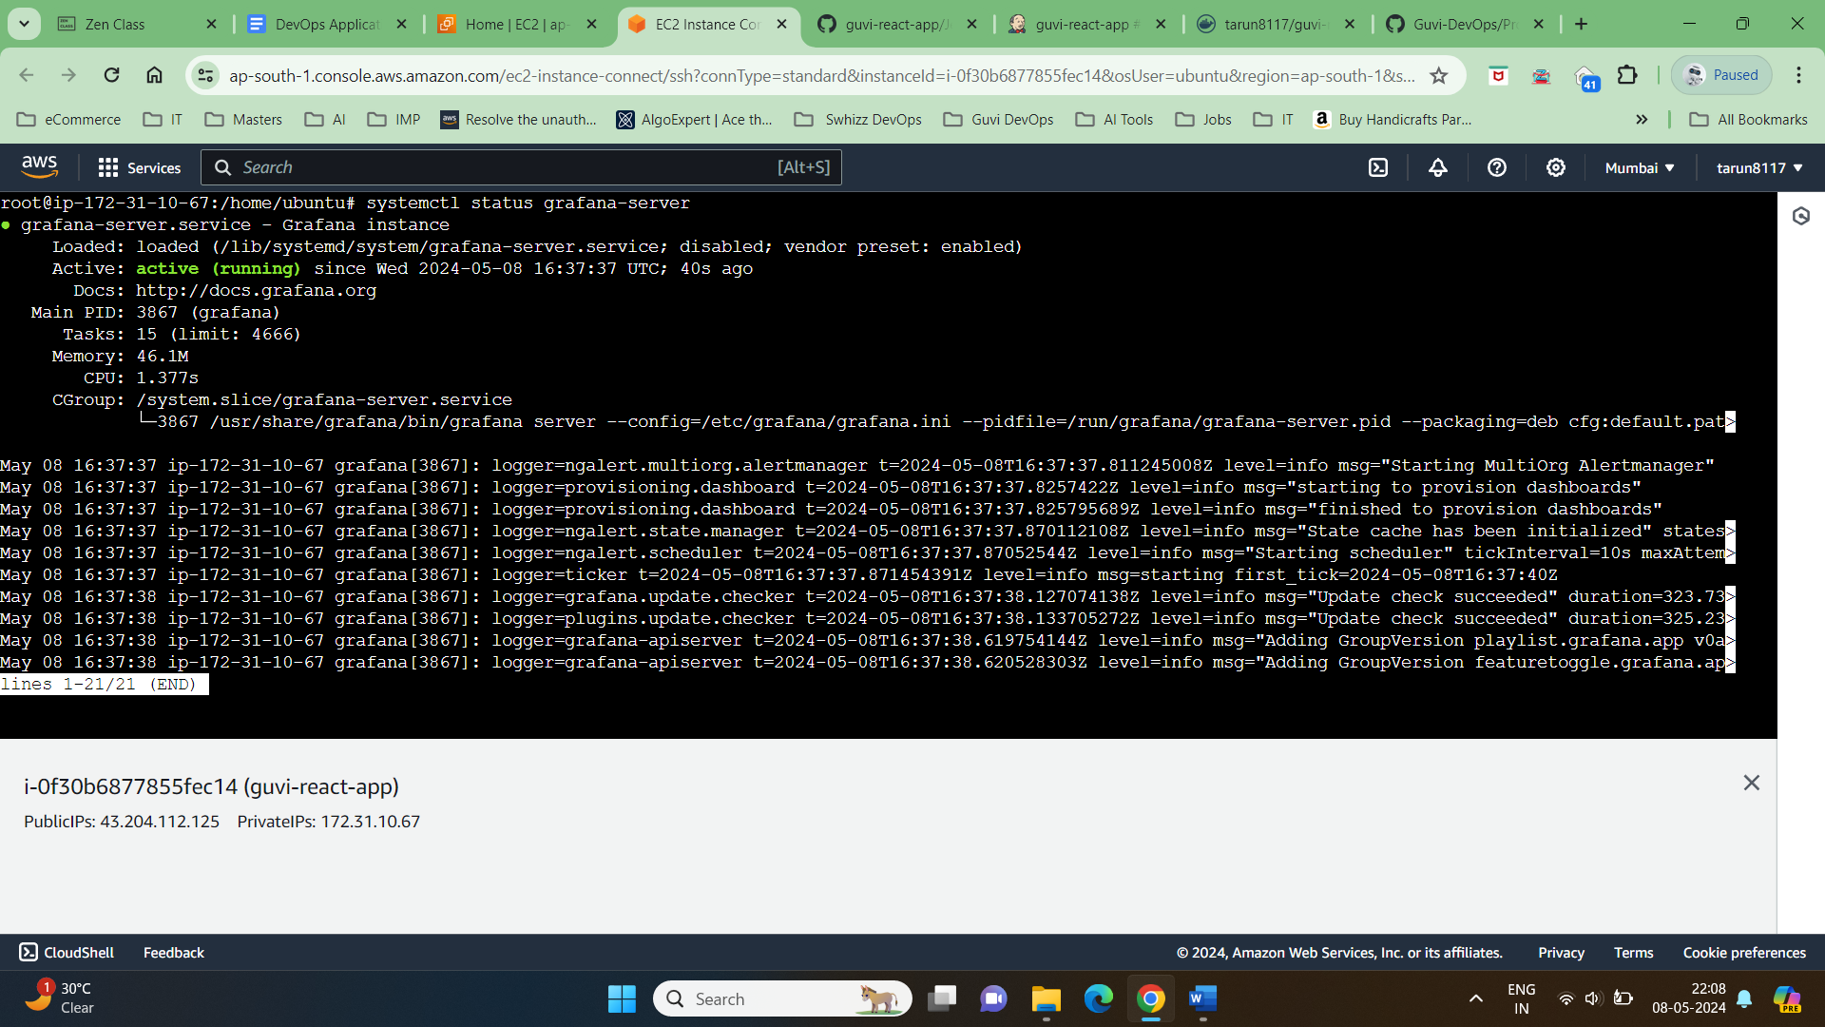

Configure the Docker daemon to expose metrics on port 9323 using the provided JSON config and put this file here /etc/docker/daemon.json

**{**

**"metrics-addr" : "0.0.0.0:9323",**

**"experimental" : true**

**}**

It enables the Docker daemon to expose metrics on port 9323 for Prometheus scraping. In your Prometheus configuration (prometheus.yml), you define a scrape job to target the Docker daemon on port 9323. This allows Prometheus to collect Docker engine metrics.

Go to /etc/prometheus and edit the prometheus.yml file. Put the below config in that file.

**# Sample config for Prometheus.**

**global:**

**scrape_interval: 15s # Set the scrape interval to every 15 seconds. Default is every 1 minute.**

**evaluation_interval: 15s # Evaluate rules every 15 seconds. The default is every 1 minute.**

**# scrape_timeout is set to the global default (10s).**

**# Attach these labels to any time series or alerts when communicating with**

**# external systems (federation, remote storage, Alertmanager).**

**external_labels:**

**monitor: 'example'**

**# Alertmanager configuration**

**alerting:**

**alertmanagers:**

**- static_configs:**

**- targets: ['localhost:9093']**

**# Load rules once and periodically evaluate them according to the global 'evaluation_interval'.**

**rule_files:**

**- "rules.yml"**

**# - "second_rules.yml"**

**# A scrape configuration containing exactly one endpoint to scrape:**

**# Here it's Prometheus itself.**

**scrape_configs:**

**# The job name is added as a label `job=<job_name>` to any timeseries scraped from this config.**

**- job_name: 'prometheus'**

**# Override the global default and scrape targets from this job every 5 seconds.**

**scrape_interval: 5s**

**scrape_timeout: 5s**

**# metrics_path defaults to '/metrics'**

**# scheme defaults to 'http'.**

**static_configs:**

**- targets: ['localhost:9090']**

**- job_name: node**

**# If prometheus-node-exporter is installed, grab stats about the local**

**# machine by default.**

**static_configs:**

**- targets: ['localhost:9100']**

**- job_name: 'docker'**

**static_configs:**

**- targets: ['localhost:9323']**

Put the below config in rules.yml file in /etc/prometheus/ folder.

**groups:**

**- name: docker_alert_rules**

**rules:**

**- alert: DockerContainerStopped**

**expr: engine_daemon_container_states_containers{instance="localhost:9323",job="docker",state="stopped"} > 0**

**for: 1m**

**labels:**

**severity: critical**

**annotations:**

**summary: "Docker container 'sample' has stopped"**

**description: "The Docker container named 'sample' has stopped running."**

Put the below config in alertmanager.yml file in /etc/prometheus folder.

**global:**

**resolve_timeout: 5m**

**route:**

**group_by: ['docker_monitoring']**

**group_wait: 10s**

**group_interval: 5m**

**repeat_interval: 3h**

**receiver: 'email-notification'**

**receivers:**

**- name: 'email-notification'**

**email_configs:**

**- to: 'tarunmaws@gmail.com'**

**from: 'tarunmalempati@gmail.com'**

**smarthost: 'smtp.gmail.com:587'**

**auth_username: 'tarunmalempati@gmail.com'**

**auth_password: 'hqikoyuhqgtutjdu'**

**auth_secret: 'hqikoyuhqgtutjdu'**

**auth_identity: 'tarunmalempati@gmail.com'**

Restart the prometheus and alertmanager using the commands **systemctl restart prometheus** and **systemctl restart prometheus-alertmanager.**

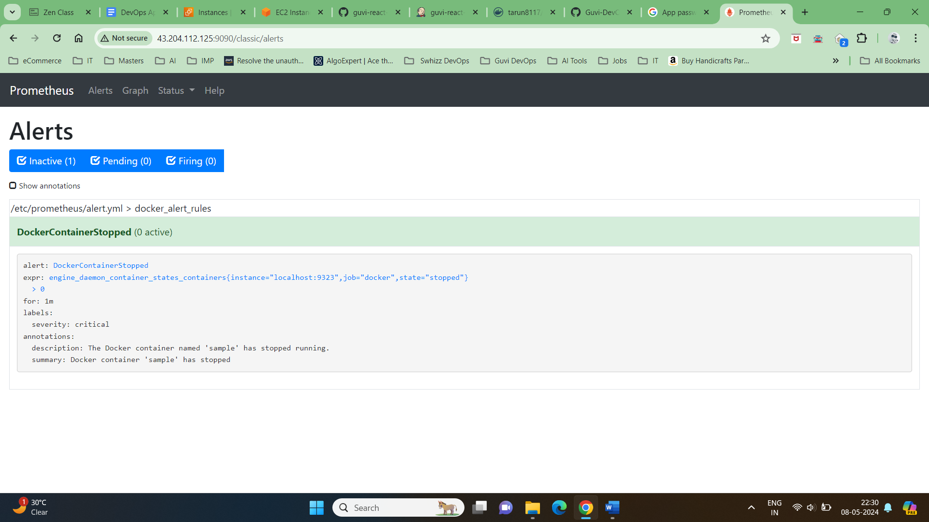

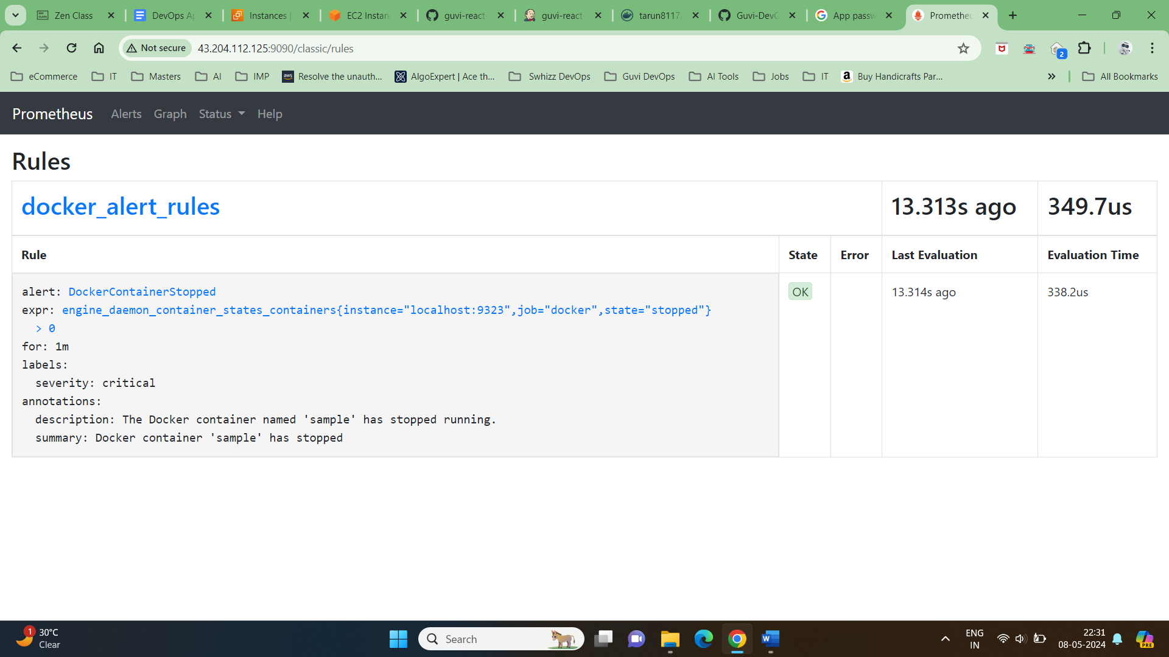

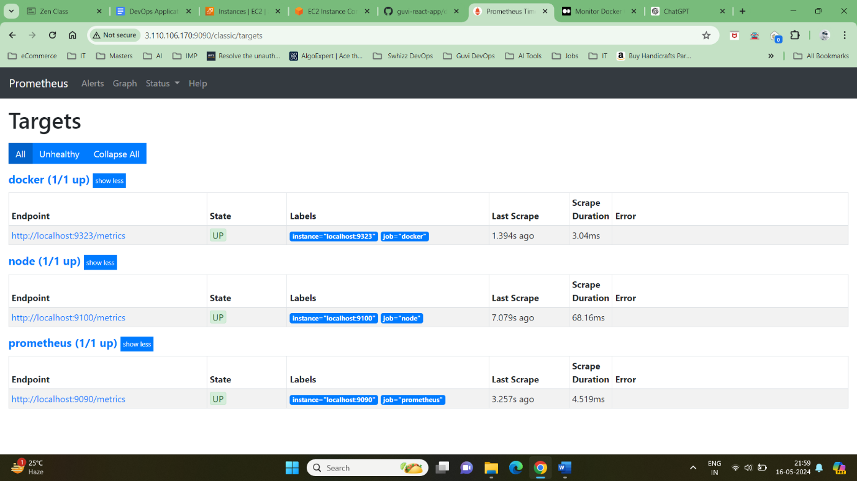

The below screenshots show the number of containers running.

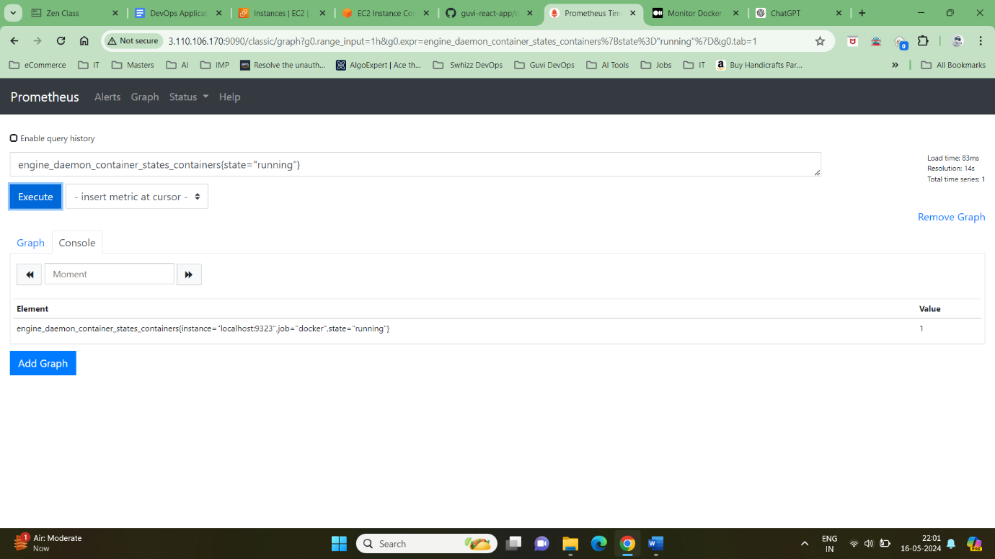

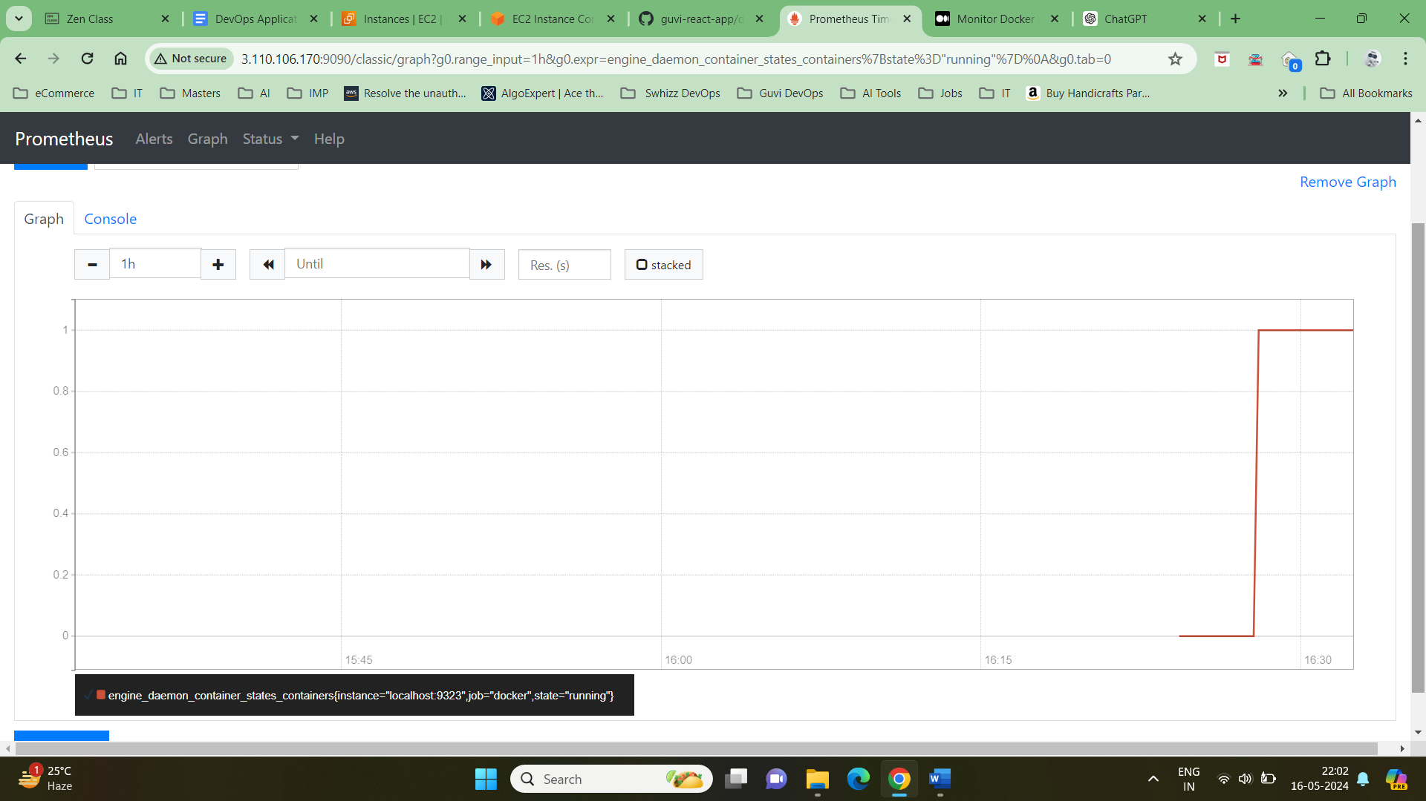

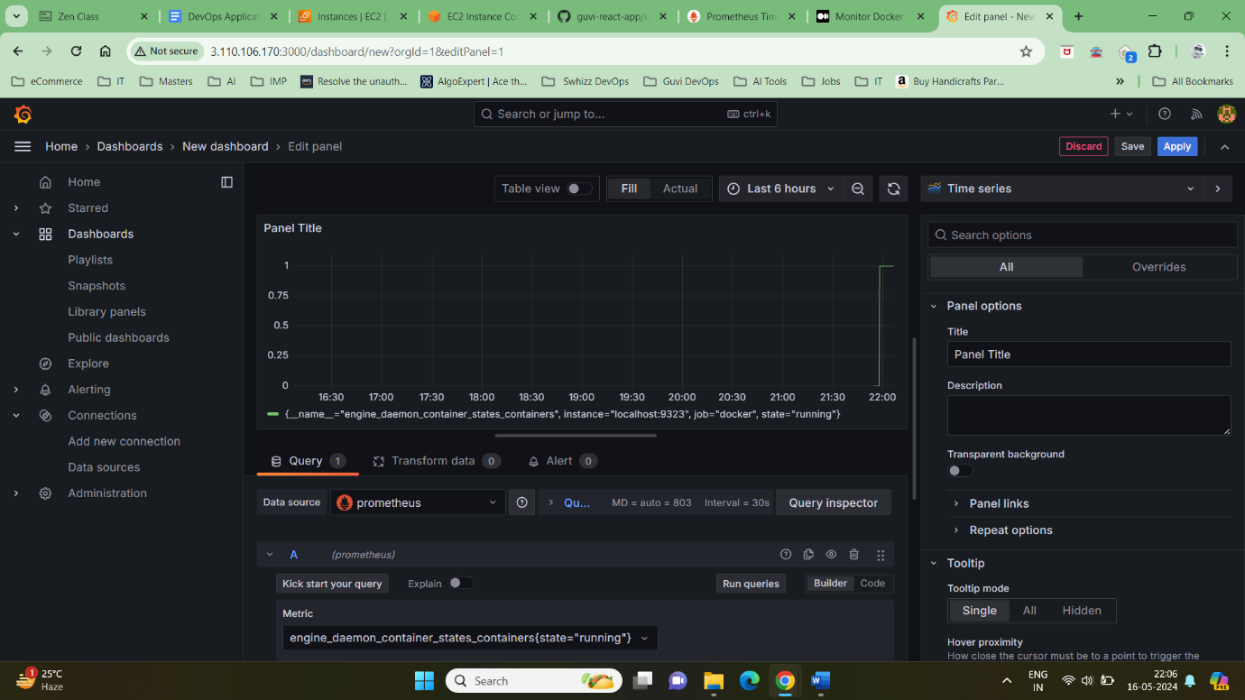

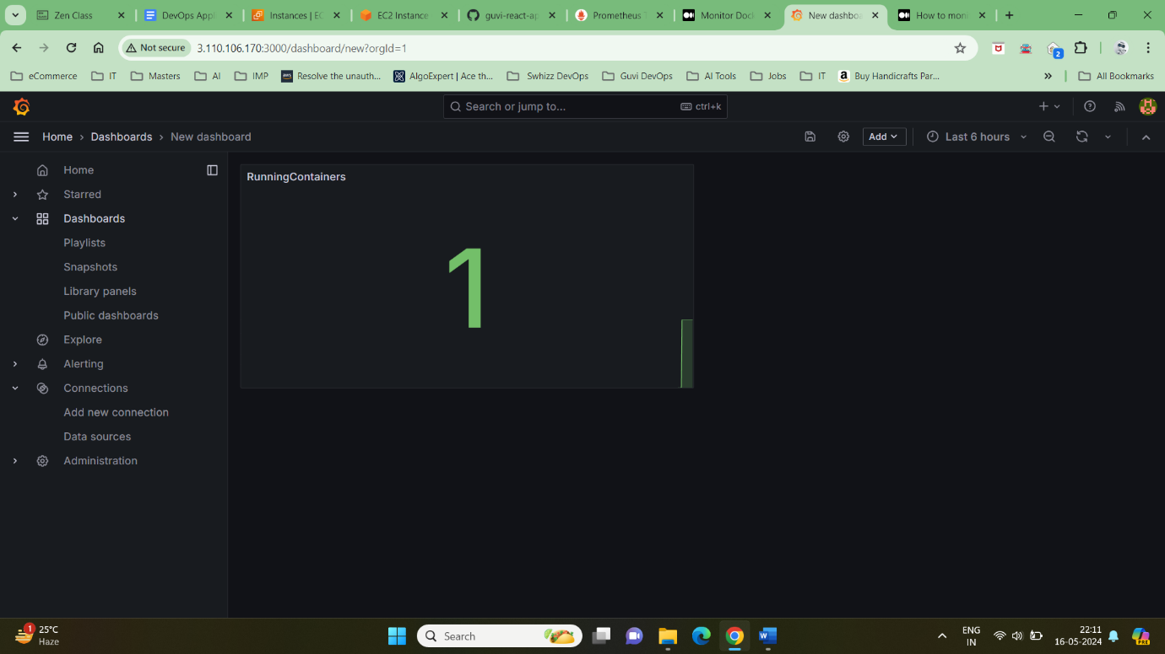

The below screenshots show the number of containers stopped.

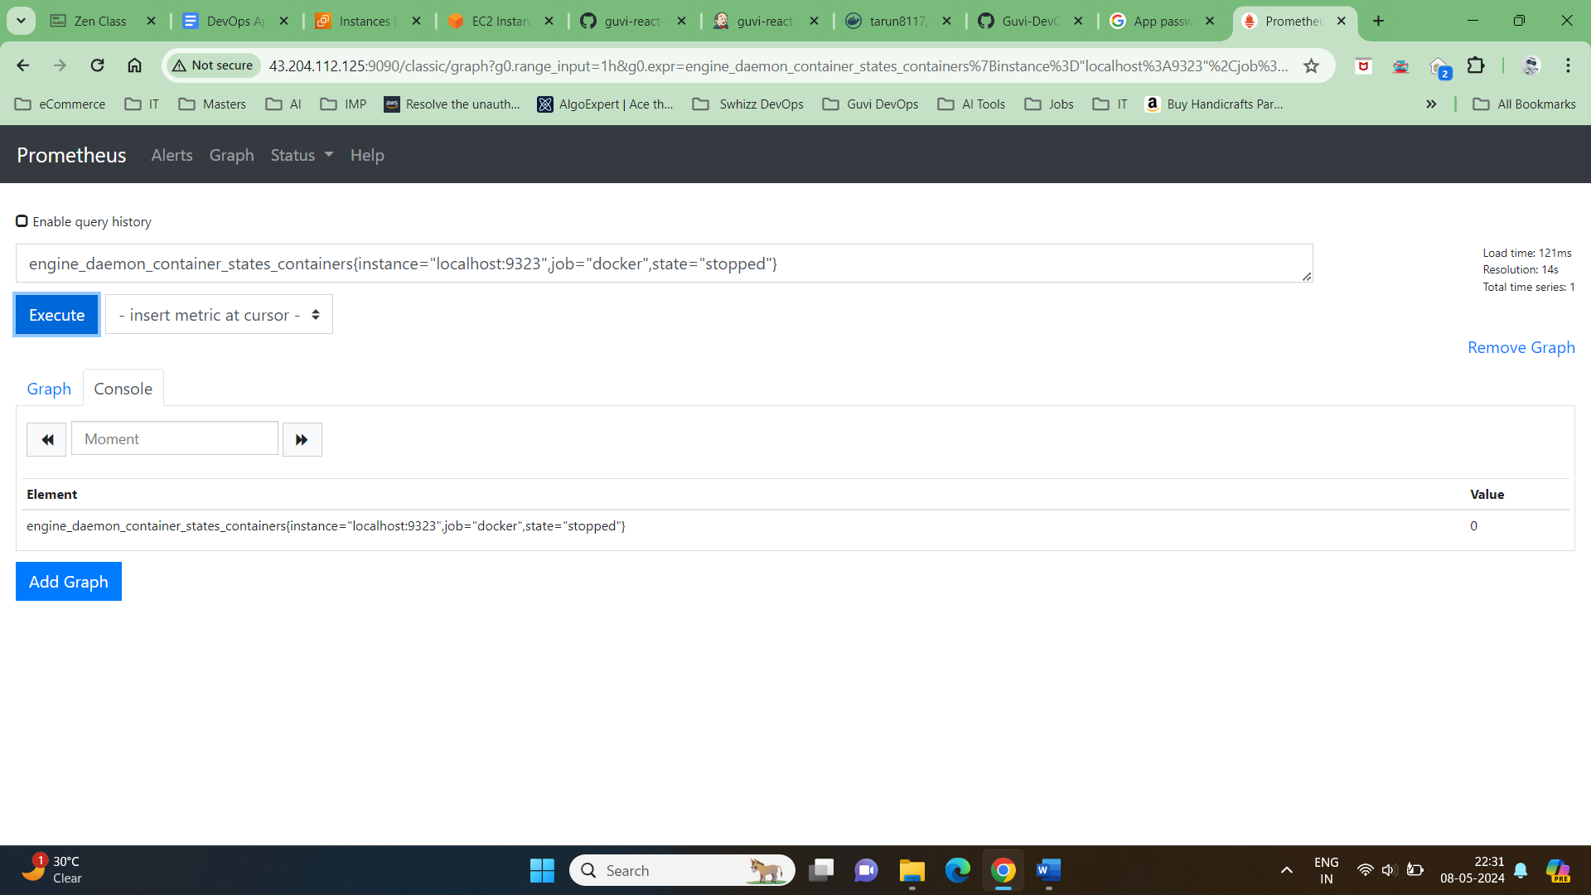

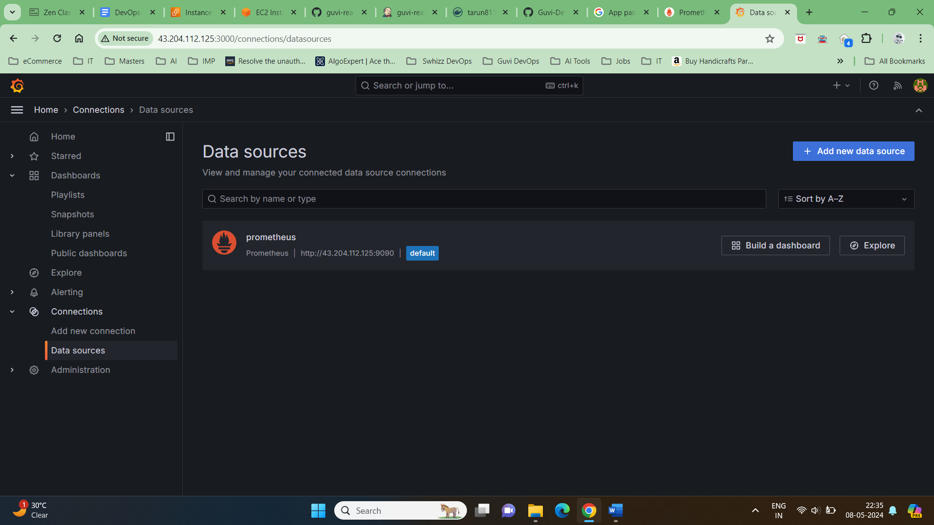

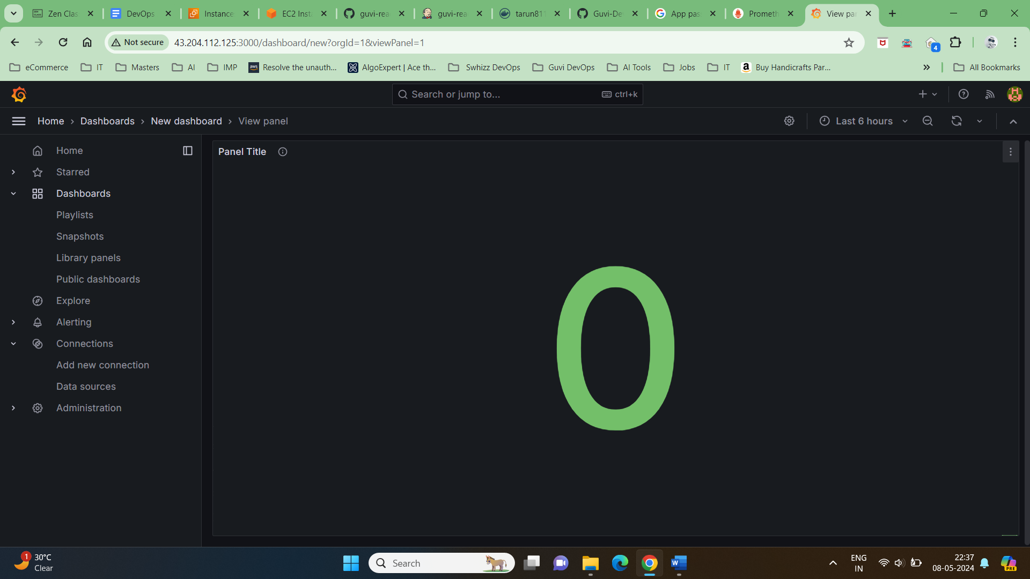

Stop the container using the command **docker stop react-app** to check if it generates alerts.

